AgriQual
SPROJ Report



ZARAK QADIR KHAN 26100370
SYEDA UMAIMA HASAN 26100219
MISHAAL USMAN 26100247
MUHAMMAD WALID KHALID 26100259

Advisor: Waqar Ahmed
School of Science and Engineering
Lahore University of Management Sciences
Submission Date: 03/05/2026

Acknowledgement and Dedication

Certificate
I certify that the senior project titled “Add project title here” was completed under my supervision by the following students:

___________________________________________________________________
___________________________________________________________________
___________________________________________________________________

and the project deliverables meet the requirements of the program.

------------------------------------- Date:
Advisor (Signature)

------------------------------------- Date:
Co-advisor (if any)

Table of Contents
Table of Contents 4
List of Figures 6
1. Introduction 7
Introduction 8
Objective and Scope 8
Development Methodology 9
Contributions 9
2. System Requirements 11
System Actors 11
Functional Requirements 11
Non-functional Requirements 13
3. System Architecture 15
Architecture Diagram 16
Architecture Description 17
1. Client Layer 17
2. Edge and Access Layer 17
3. Core Services & AI Agents 17
4. Data and Storage Layer 18
5. Messaging and Orchestration 19
6. ML Ops and Analytics 19
7. External Integrations 19
8. Runtime Interactions 20
Justification of the Architecture 20
Tools and Technologies 22
4. Requirements Specifications 25
Use Cases 25
Class Diagram 42
Sequence Diagrams 42
Upload Wheat Image for Diagnosis 45
Manage Wheat Fields/Plots 47
Receive Weather Alerts 51
Generate Inspection Statistics 52
5. Software Development Methodology and Plan 52
Software Process Selection 52
6. Database Design and Web Services 55
Database Design 55
API Specification 57
7. System User Interface 60
What people actually see 60
Signing in and creating an account 60
For farmers: the day-to-day screen 61
For administrators 64
8. Project Security 66
How we think about security 66
STRIDE in practice (what we actually mitigate) 66
Static analysis: SonarCloud 67
What STRIDE + Sonar do not replace 67
9. Risk Management 68
Potential Risks and Mitigation Strategies 68
10. Testing and Evaluation 71
Testing strategy we followed 71
Sample test cases 71
Functional + UI test cases (implemented) 71
AI-related test cases 73
Automation tools used 74
Evaluation summary 74
11. Deployment Guidelines 75
12. Conclusion 79
Summary 79
Challenges 79
Future 80
13. Review checklist 82
14. References 83

List of Figures

Introduction

Introduction
AgriQual is an AI-driven web platform designed to support Pakistani wheat farmers by delivering personalized, real-time agricultural intelligence. Pakistan's agricultural sector accounts for a significant share of national GDP and employs the majority of its rural population, yet farmers frequently lack access to timely expert advice on crop disease, weather risk, and field management. AgriQual addresses this gap by combining computer vision, a large language model-powered advisory system, and live weather integration into a single, accessible web application.
The platform targets three primary domains: crop disease diagnosis through image-based machine learning, weather-aware field advisory through integration with live meteorological data, and knowledge retrieval through a Retrieval-Augmented Generation (RAG) chat interface grounded in agricultural literature.
AgriQual's primary users are wheat farmers who need actionable crop health assessments without specialist access. The system also provisions roles for Quality Inspectors and System Administrators. The product is delivered as a Progressive Web Application accessible via browser on desktop and mobile, with a separate React-based frontend hosted on Vercel and a Node.js API backend hosted on Oracle.

Objective and Scope
The core objective of AgriQual is to reduce crop losses among Pakistani wheat farmers by making expert-level disease diagnosis and weather advisory available at zero cost and without specialist intermediaries. Specific objectives include:
- Providing automated wheat disease diagnosis with confidence scores and actionable treatment recommendations within 15 seconds of image upload.
- Delivering weather-aware irrigation and spraying advisories derived from live Open-Meteo data, enhanced by GPT-4.1-mini narrative summaries.
- Offering a RAG-powered bilingual (English/Urdu) chat interface grounded in curated agricultural knowledge base documents.
- Enabling farmers to register, manage, and monitor the health scores of their wheat fields over time.
- Providing administrators with an operational dashboard covering SLA compliance, diagnosis analytics, complaint management, and user administration.
The scope of the current release covers the Farmer and Administrator roles in full. The Quality Inspector role has been architected and provisioned in the RBAC system but its associated workflows (crop quality assessment, compliance certificate generation) are deferred to a future release.

Development Methodology
The project followed an Agile development methodology with two-week sprints. The team began with a requirements-gathering and design phase covering system actors, use cases, class diagrams, and architecture decisions. Development then proceeded iteratively, with each sprint targeting a specific feature module: authentication and RBAC, ML microservice and diagnosis pipeline, weather dashboard, RAG chat, field management, and the admin dashboard.
Version control was managed on GitHub with a main branch protected by pull-request reviews. Docker Compose was used throughout local development to ensure environment parity across all four team members. Automated testing was integrated incrementally using Jest for unit tests and Cypress for end-to-end regression. The CI/CD pipeline (GitHub Actions) was configured in the final sprint to automate builds and deployments to Oracle Kubernetes Engine.

Contributions
The development of AgriQual was inspired by AgriSense, a precision agriculture platform built by another team that demonstrated the viability of using AI for wheat crop analysis. AgriSense focused on two tasks: crop disease detection and yield estimation, using a CNN-based object detection model trained on the Global Wheat Head Detection Dataset. While effective as a proof of concept, AgriSense was limited to image-based analysis and did not provide broader advisory capabilities, multi-role access, or integration with external data such as weather. AgriQual was designed to address these gaps and deliver a more complete agricultural intelligence system.
AgriQual’s contributions center on four areas. First, the ML pipeline is upgraded to a TorchScript-serialized PyTorch model served via a dedicated FastAPI microservice, returning top-3 predictions with individual confidence scores and rule-based treatment recommendations rather than a single classification output. This makes the system’s uncertainty visible to the farmer and provides actionable next steps alongside the diagnosis. Second, a RAG-powered advisory chatbot combines the active diagnosis result, real-time weather data, and a domain knowledge base embedded from agricultural PDFs to generate grounded, cited responses via GPT-4.1-mini. This goes beyond what any single-purpose disease classifier offers by providing context-aware agronomic guidance within the same interface. Third, a real-time weather dashboard integrates Open-Meteo data to produce bilingual English and Urdu irrigation and spraying advisories, supplemented by an LLM-generated narrative summary and a background scheduler that automatically emails weather alerts to farmers for their registered fields. Fourth, a full admin tooling layer provides a complaint queue with email response capability, SLA monitoring on ML inference times with breach alerting, diagnosis analytics with disease distribution and confidence trends, and broadcast email to all users. These capabilities collectively distinguish AgriQual from single-purpose agri-AI tools and position it as an integrated platform for wheat farmers, inspectors, and administrators.

System Requirements
This section outlines the key actors who engage with AgriQual, the functional capabilities the system provides to each actor, and the non-functional requirements that guide the system’s overall performance and reliability.

System Actors

Actor Name | Description
Farmer | Primary end-user who uses the system to get personalized advice by providing crop images, soil data and queries.
System Administrator | Technical personnel responsible for managing system operations, security and technical issues at the back end.
AI Agents | Vision, Climate and Advisory agents that analyze data and generate insights for farmers.

Functional Requirements

Requirements of Farmer
Sr# | Requirement
1 | I want to register for this app.
2 | I want to upload images of my crops for feedback and pest diagnosis
3 | I want to receive weather forecasts to plan my irrigation and fertilizer application

Requirements of AI Agents
Sr# | Requirement
1 | I want to process uploaded crop images to detect diseases, pests and nutrient deficiencies.
2 | I want to analyze weather and climate data to provide timely forecasts and risk alerts.
3 | I want to generate personalized recommendations by combining vision and climate insights.
4 | I want to continuously learn from new data and expert feedback to improve accuracy.
5 | I want to provide accurate responses to farmers queries in a clear and actionable format.

Requirements of System Administrator
Sr# | Requirement
1 | I want to manage user accounts and access permissions.
2 | I want to maintain data integrity, backups, and security.
3 | I want to monitor system performance and ensure smooth operation.
4 | I want to update and configure AI models when improvements are available.
5 | I want to troubleshoot and resolve technical issues reported by users.

Non-functional Requirements
Sr# | Requirements
1 | The system should process and classify an uploaded image in less than 15sec
2 | The system should support at least 100 concurrent users
3 | The system should provide a confidence score for each prediction
4 | The system should have a simple and intuitive interface where most user tasks are completed in 2-3 clicks.
5 | The system should handle an increase in dataset size(adding new crops)
6 | The system should provide clear error logs for troubleshooting
7 | The system should retrieve weather data within 30 seconds of a request from the advisory agent to ensure timely recommendations for farming activities
8 | Certificate generation should complete within 5 seconds for single quality assessments
9 | Statistical reports should process 1000 assessment records within 10 seconds.
10 | The system should support crop image uploads up to 10MB.
11 | Notifications should be delivered within 10-20 seconds of system events.
12 | Weather alerts must reach users within 5-10 minutes for severe weather warnings.

System Architecture

Architecture Diagram
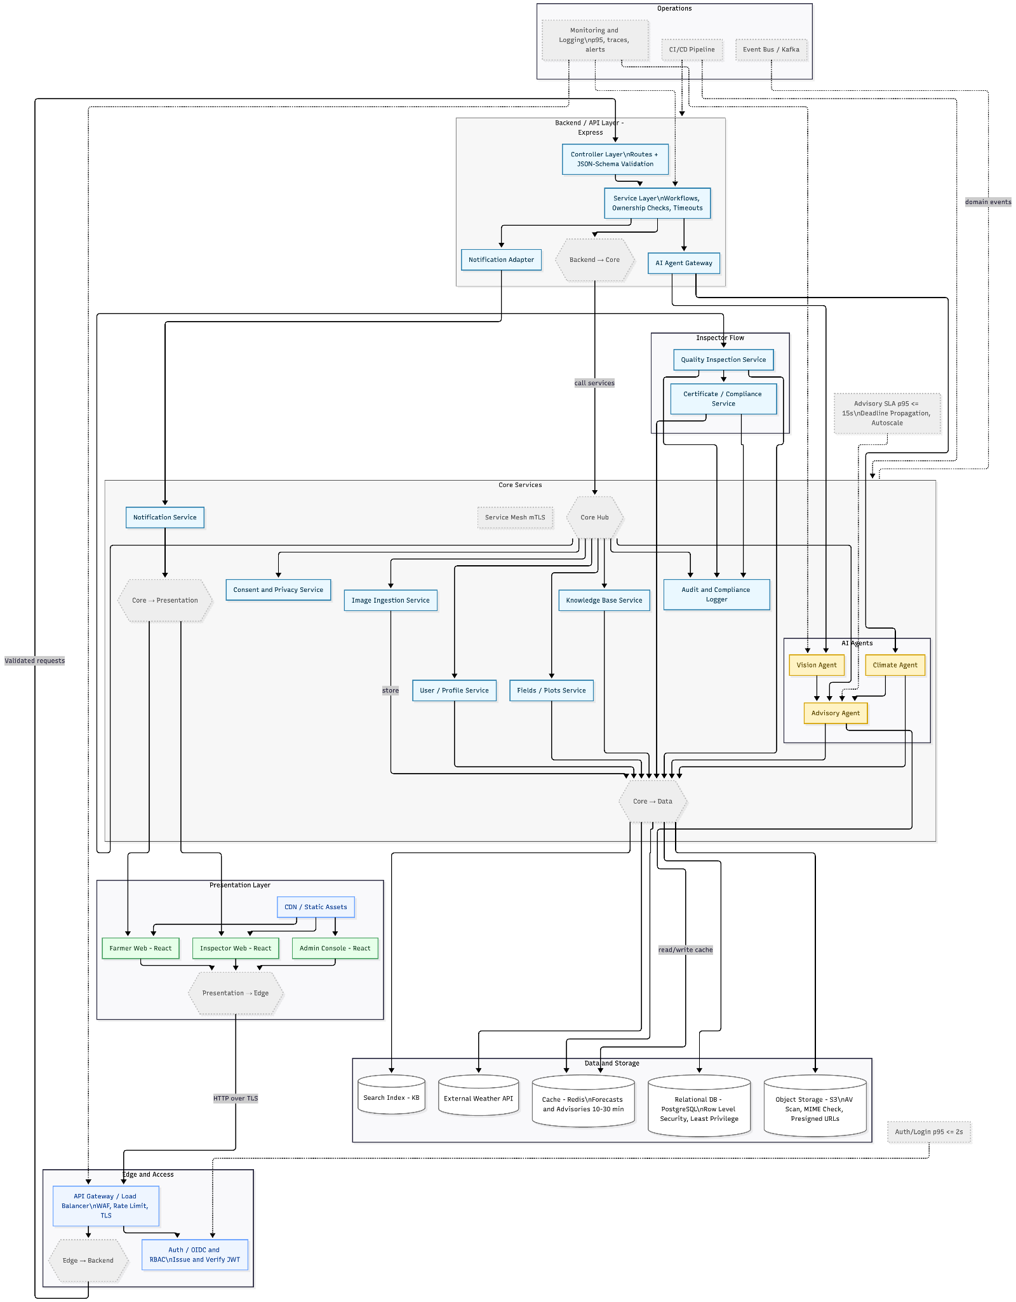

Architecture Description
The AgriQual system follows a modular, service-oriented, cloud-native architecture that combines the MERN stack (MongoDB, Express.js, React.js, Node.js) with AI-driven microservices and event-based orchestration. The design supports scalability, high availability, and maintainability while enforcing strict data governance and SLA monitoring.

1. Client Layer
The presentation tier consists of responsive web and mobile interfaces for distinct user roles.
- Farmer App (Mobile/Web):
Captures crop photos, GPS location, and crop metadata; displays diagnoses, advisories, and localized weather updates.
Utilizes pre-signed URLs for efficient image uploads and receives push/SMS notifications for timely interventions.
- Inspector App (Tablet/Web):
Allows inspectors to upload batch images, record grading data, and generate compliance certificates.
Supports role-based approvals, overrides, and report exports.
- Admin / Analyst Console:
Provides dashboards to manage users, monitor SLAs, update AI models, and review system metrics.
Enables audit review, consent management, and model lifecycle control.

2. Edge and Access Layer
This layer secures and optimizes access to backend services.
- CDN / Static Assets: Caches static content (JS, CSS, media) to reduce latency.
- API Gateway & WAF: Acts as a unified ingress for client requests, handling routing, rate limiting, and request validation.
- Authentication & RBAC: Implements OAuth2/OIDC standards for token issuance and enforces role-based permissions (Farmer, Inspector, Admin).

3. Core Services & AI Agents
The core layer encapsulates the main business logic and intelligence services.
- Image Ingestion Service: Handles uploads, performs virus scans and normalization, and stores media in Object Storage (S3).
Emits domain events (image_uploaded) for downstream processing.
- Vision Agent (Inference Service): Uses GPU-optimized models to detect diseases, pests, and severity from uploaded crop images.
Ensures SLA compliance (≤15 s per image) using autoscaling and caching.
- Climate Agent / Weather Service: Retrieves real-time weather and satellite data, calculates localized risk indices, and stores time-series data for analytics.
- Advisory / Rules Engine: Combines outputs from Vision and Climate Agents with agronomic knowledge to generate personalized, actionable recommendations.
Incorporates PHI/WHI safety, crop calendars, and region-specific rules.
- Quality Inspection Service: Supports inspectors in grading produce, generating remediation advice, and issuing compliance certificates.
- Knowledge Base Service: Hosts FAQs, guides, and contextual help. Integrates with the advisory module for why this advice explanations.
- User & Profile Service: Manages farms, plots, preferences, and notifications.
- Privacy & Consent Service: Logs consent and governs data use for AI training or sharing.
- Notification Service: Sends push, SMS, WhatsApp messages and schedules reminders.
- Audit & Compliance Logger: Maintains immutable trails of system activity.
- SLA Guardrail: Monitors p95 latency and automatically triggers autoscaling or alerts on threshold breaches.

4. Data and Storage Layer
A combination of polyglot storage solutions ensures optimized data management.
- Object Storage: Stores raw images, derived masks, and model artifacts.
- Relational Database (PostgreSQL): Maintains user, advisory, and inspection data.
- Time-Series Database: Logs weather metrics and service performance.
- Cache (Redis): Caches advisories, forecasts, and authentication sessions.
- Search Index: Enables full-text search in the Knowledge Base.
- Feature Store: Provides versioned features for online and batch ML pipelines.
- Data Lake & Warehouse: Stores long-term datasets for analytics and BI.
- Model Registry: Tracks model versions, metadata, and deployment lineage.

5. Messaging and Orchestration
The system relies on asynchronous, event-driven communication for scalability.
- Event Bus (Kafka): Publishes and subscribes to domain events such as image_uploaded, advisory_issued, inspection_submitted.
- Work Queues / DLQ: Handles background processing and retries.
- Workflow Orchestrator: Coordinates multi-step pipelines (e.g., Ingest, Vision, Fuse, Notify).

6. ML Ops and Analytics
Supports the full lifecycle of AI model training and deployment.
- ETL and Training Pipelines: Periodically train models from curated data.
- Experiment Tracking: Logs hyperparameters, datasets, and evaluation metrics.
- Batch Scoring: Runs nightly jobs for regional risk mapping and campaign targeting.
- Canary Rollouts: Gradual deployment of new models with automated rollback on SLA or quality regressions.

7. External Integrations
- Weather APIs: Pull official meteorological data with rate limits and fallback providers.
- Satellite Imagery: Supplies vegetation and cloud data for risk analysis.
- Messaging Gateways: Integrate with email providers

8. Runtime Interactions
Key runtime workflows demonstrate inter-service collaboration:
- Farmer Advisory Flow:
  - Farmer uploads an image → Ingestion Service stores → emits event.
  - Vision Agent detects disease → Climate Agent enriches with weather → Advisory Engine fuses results.
  - Advisory stored in DB → cached in Redis → notifications sent → audit logged.
- Inspector Grading Flow:
Inspector uploads inspection batch → Quality Inspection evaluates → stores in DB and Object Storage → issues certificates.
- Consent-Aware Processing:
Consent Service validates before any AI training or data sharing.
All downstream pipelines respect consent flags.
- Batch Analytics:
Data Lake processes aggregated insights → triggers retraining when drift is detected → updated models deployed via controlled rollout.

Justification of the Architecture

Pros and cons of the architecture

Pros | Cons
Independent Scalability: Each microservice (Vision Agent, Climate Agent, Advisory Engine) can scale independently based on load, allowing efficient resource allocation when image processing demand spikes while weather data requests remain steady. | Increased Complexity: Managing multiple microservices, event buses, and data stores can be complex and difficult to coordinate effectively
Technology Flexibility: Different services can use optimal technologies—PyTorch for Vision Agent, Node.js for API services, and specialized time-series databases for weather data—without affecting other components. | Network Latency: Inter-service communication through API Gateway and event bus introduces network overhead, that we must carefully optimize to meet the 15-second image processing requirement
Fault Isolation: Failure in one agent (e.g., Weather API timeout in Climate Agent) doesn't crash the entire system; farmers can still receive crop disease diagnoses while weather advisories are temporarily unavailable. | Data Consistency Challenges: Maintaining consistency across multiple databases (MongoDB for images, PostgreSQL for users, Redis cache) requires implementing complex synchronization logic that may be difficult to debug.
Role-Based Separation: Clear service boundaries (Farmer App, Inspector App, Admin Console) with RBAC at the API Gateway level naturally enforce access control and support regulatory compliance for agricultural data | Testing Overhead: Comprehensive testing requires unit tests for each service, integration tests across service boundaries, end-to-end tests, significantly increasing QA effort.
Polyglot Persistence: Using specialized databases (PostgreSQL for relational data, MongoDB for flexible inspection records, Time-series DB for weather, Redis for caching) optimizes performance and storage efficiency for each data type | Debugging Difficulty: Tracing requests across multiple services, event streams, and asynchronous workflows makes troubleshooting production issues more complex
MLOps Integration: Dedicated ML pipeline with model registry, feature store, and canary deployments enables continuous model improvement and safe rollout of updated disease detection algorithms without system downtime.

Tools and Technologies
Frontend
Layer / Component | Technology
Framework | React v19
Routing | React Router v6
Styling | Tailwind CSS + PostCSS v3
Charts | Recharts v3
Auth UI | @react-oauth/google
i18n | Custom LanguageContext
Testing | React Testing Library + Jest / Cypress 13
Backend
Layer / Component | Technology
Runtime | Node.js v20
Framework | Express v5
ODM | Mongoose v8
Auth | JWT + bcryptjs + Google OAuth2
Email | Resend SDK
File Upload | Multer
AI / LLM | OpenAI SDK (GPT-4.1-mini + text-embedding-3-small)
ML Microservice
Layer / Component | Technology
Framework | FastAPI + Uvicorn
ML | PyTorch v2.5
Image Processing | Pillow + NumPy
Infrastructure & Deployment
Layer / Component | Technology
Database | MongoDB v7
Cache | Redis v7-alpine
Weather API | Open-Meteo
Containerisation | Docker + Docker Compose
Frontend Hosting | Vercel
Backend Hosting | Oracle Cloud / Kubernetes (OKE)
CI/CD | GitHub Actions
Container Registry | GHCR

Requirements Specifications
Brief introduction of this chapter in a paragraph highlighting the content

Use Cases
Draw use case diagrams of your system using standard UML notation. Moreover, give description of 10 core use cases of your system
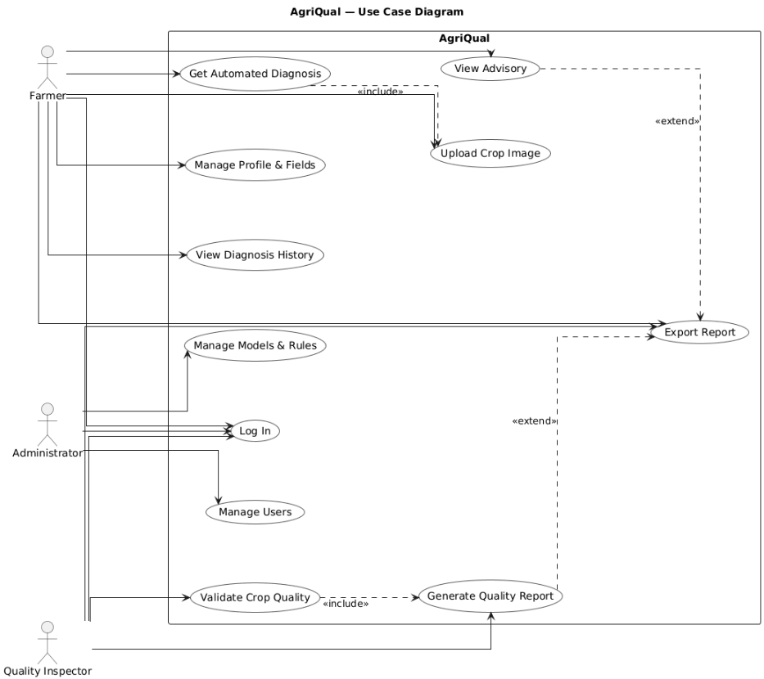

4.1 User Registration

Identifier |  | UC-001
Purpose |  | Allow a new farmer or quality inspector to create an account on the system.
Pre-conditions |  | The user is not logged in and has access to the registration page.
Post-conditions |  | A verified account is created and stored in the system with the correct role.
Step # | Typical Course of Action
1. | The user selects the “Register” option on the homepage
2. | The system displays the registration form with role options (Farmer/Inspector).
3. | The user enters name, email/phone, password, and selects a role.
4. | The system validates the entered information.
5. | The system sends an OTP/email for verification.
6. | The user enters the OTP/email verification code.
7. | The system verifies the code successfully.
8. | The account is created and linked to the chosen role.
9. | The system redirects the user to their dashboard.
10. | The use case ends.
Step # | Alternate Courses of Action
1. | In step 1, if the user selects 'Sign up with Google/Apple', the system redirects to the provider and fetches verified details.
2. | In step 5, if the OTP is not received, the user may request a resend and the system issues a new code.
3. | At step 4, the system flags weak passwords. System shows strength meter and suggestions; user updates password. Continue at step 5.
Step # | Exception Paths
1. | In step 3, if the email/phone format is invalid, the system shows an error and asks the user to correct it.
2. | In step 4, if the email/phone is already registered, the system stops registration and offers Login/Password Recovery.
3. | In step 6, if the OTP entered is incorrect three times, the system locks verification temporarily.
4. | In step 8, if the database fails to create the account, the system rolls back and shows an error message.

4.2 Secure Login

Identifier |  | UC-002
Purpose |  | Allow registered users to securely log in and access the system.
Pre-conditions |  | The user has a registered and verified account.
Post-conditions |  | A secure session is created, and the user is redirected to their dashboard.
Step # | Typical Course of Action
1. | The user selects the 'Login' option on the homepage.
2. | The system displays the login form.
3. | The user enters email/phone and password.
4. | The system validates the credentials.
5. | If credentials are correct, the system establishes a secure session.
6. | The system redirects the user to the appropriate dashboard (Farmer/Inspector).
7. | The use case ends.
Step # | Alternate Courses of Action
1. | In step 1, if the user chooses 'Login with Google/Apple', the system redirects to the provider and retrieves verified credentials.
2. | In step 2, if the user selects 'Forgot Password', the system sends a reset link or OTP and guides the user through resetting their password before returning to login.
3. | In step 5, if there is an existing active session on another device, the system notifies the user and provides the option to continue or terminate the other session.
Step # | Exception Paths
1. | In step 3, if the user enters an invalid email/phone format, the system shows an error and requests correction.
2. | In step 4, if the credentials are incorrect, the system displays an error and allows limited retries.
3. | In step 4, if the account is locked after multiple failed attempts, the system denies login and instructs the user to reset their password or contact support.

4.3 Upload Wheat Image for Diagnosis

Identifier |  | UC-003
Purpose |  | Farmers upload wheat images to detect diseases or pest issues.
Pre-conditions |  | The farmer is logged in and has access to the upload feature.
Post-conditions |  | The uploaded image is processed, and a diagnostic result is stored.
Step # | Typical Course of Action
1. | The farmer selects the 'New Wheat Diagnosis' option.
2. | The system displays an image upload/camera option.
3. | The farmer uploads or captures a wheat image (leaf, stem, or ear).
4. | The system validates the file format and size.
5. | The system processes the image using the vision agent.
6. | The advisory agent generates a diagnosis and recommendations.
7. | The system displays the diagnosis result to the farmer.
8. | The result is saved to the farmer's history.
9. | The use case ends.
Step # | Alternate Courses of Action
1. | In step 3, if the farmer cancels the upload midway, the system discards the current request and returns to the dashboard.
2. | In step 3, if the uploaded image is blurry or low-quality, the system prompts the farmer to retake or enhance the image before proceeding.
Step # | Exception Paths
1. | In step 3, if the file format is unsupported or the image size exceeds the limit, the system rejects the upload and informs the farmer of acceptable formats and sizes.
2. | In step 6, if the advisory agent fails to generate recommendations, the system shows a generic advisory and logs the error for review.
3. | In step 8, if saving the diagnosis record to the database fails, the system alerts the farmer and allows retry.

4.4 Get Weather-Aware Advisory

Identifier |  | UC-004
Purpose |  | Provide wheat farmers with crop care recommendations based on weather forecasts.
Pre-conditions |  | The farmer has at least one registered wheat field or a recent diagnosis.
Post-conditions |  | An advisory is generated, displayed to the farmer, and stored in the system for reference.
Step # | Typical Course of Action
1. | The farmer opens the 'Advisory' section from the dashboard.
2. | The system retrieves the farmer’s registered field location.
3. | The system fetches the latest weather forecast for that location (temperature, rainfall, humidity, wind).
4. | The system combines weather data with wheat growth stage and health information.
5. | The system generates tailored recommendations (e.g., irrigation schedule, spraying window, fertilizer timing).
6. | The system displays the advisory to the farmer in an easy-to-read format.
7. | The system saves the advisory to the farmer’s history for future reference.
8. | The use case ends.
Step # | Alternate Courses of Action
1. | In step 2, if no field location is registered, the system prompts the farmer to set a location manually before continuing.
2. | In step 4, if the farmer selects a different crop stage than the default, the system recalculates the advisory based on the chosen stage.
Step # | Exception Paths
1. | In step 2, if the system cannot retrieve the farmer’s field location due to missing data, it displays an error and requests manual input.
2. | In step 3, if the weather API is unavailable, the system uses cached forecast data (if available) and shows a warning.
3. | In step 3, if the forecast data returned is incomplete or corrupted, the system informs the farmer and defaults to generic advisories.
4. | In step 4, if crop growth stage data is missing, the system asks the farmer to input the stage manually before proceeding.

4.5 Manage Wheat Fields/Plots

Identifier |  | UC-005
Purpose |  | Allow farmers to add, update, and manage their wheat fields.
Pre-conditions |  | The farmer is logged in.
Post-conditions |  | Field information is saved and linked to crop history.
Step # | Typical Course of Action
1. | The farmer selects the 'My Fields' option from the dashboard.
2. | The system displays a list of the farmer’s existing wheat fields (if any).
3. | The farmer chooses to add a new field, edit an existing one, or delete a field.
4. | For adding or editing, the farmer enters details (field name, area, location, wheat variety, sowing date).
5. | The system validates the entered information.
6. | The system saves the field details to the database.
7. | The system updates the list of fields displayed to the farmer.
8. | The use case ends.
Step # | Alternate Courses of Action
1. | In step 2, if no fields are registered, the system shows a message 'No fields found' and prompts the farmer to add a new field.
2. | In step 3, if the farmer chooses 'Copy Field', the system duplicates an existing field entry and allows quick edits before saving.
Step # | Exception Paths
1. | In step 4, if required details (e.g., location or variety) are missing, the system highlights missing fields and blocks submission until completed.
2. | In step 4, if invalid data is entered (e.g., negative area size, invalid date), the system rejects it and prompts correction.

4.6 View Diagnosis History

Identifier |  | UC-006
Purpose |  | Allow farmers to view and track past wheat diagnoses.
Pre-conditions |  | The farmer has at least one past diagnosis record in the system.
Post-conditions |  | The farmer can see their diagnosis history, filter records, and export reports if needed.
Step # | Typical Course of Action
1. | The farmer selects the 'History' option from the dashboard.
2. | The system retrieves all past diagnosis records for the farmer.
3. | The system displays the records in a list with details such as date, field, issue type, and result.
4. | The farmer applies filters (by field, date range, or issue type) to narrow down results.
5. | The system updates the list based on the filters applied.
6. | The farmer clicks on a diagnosis entry to view detailed information.
7. | The farmer optionally exports the history as a PDF or CSV report.
8. | The use case ends.
Step # | Alternate Courses of Action
1. | In step 2, if the farmer has many records, the system paginates results and provides navigation controls.
2. | In step 3, if the farmer sorts by date or issue type, the system reorders the list accordingly.
3. | In step 4, if no filters are applied, the system shows the complete unfiltered list by default.
Step # | Exception Paths
1. | In step 2, if the farmer has no past records, the system shows 'No diagnosis history found' with a link to upload a new diagnosis.
2. | In step 5, if invalid filter criteria are applied, the system ignores the filter and shows a warning message.
3. | In step 7, if the report export service fails, the system notifies the farmer and allows retry.

4.7 Farmer Updates Wheat Field Information

Identifier |  | UC-007
Purpose |  | Allow farmers to update details of their registered wheat fields.
Pre-conditions |  | The farmer has at least one registered wheat field in the system.
Post-conditions |  | The updated field details are saved and reflected in the farmer’s profile.
Step # | Typical Course of Action
1. | The farmer selects the 'My Wheat Fields' option from the dashboard.
2. | The system displays a list of registered wheat fields.
3. | The farmer selects a specific field to edit.
4. | The system shows the current details of the selected field (variety, area, sowing date, etc.).
5. | The farmer modifies one or more field details.
6. | The system validates the updated details.
7. | The system saves the updated field information to the database.
8. | The updated field list is shown to the farmer.
9. | The use case ends.
Step # | Alternate Courses of Action
1. | In step 2, if the farmer has many fields, the system provides a search bar or filter to quickly locate a specific field.
Step # | Exception Paths
1. | In step 3, if the selected field does not exist or was deleted by mistake, the system shows 'Field not found' and prevents editing.
2. | In step 5, if the farmer enters invalid data (e.g., negative area size, incorrect date format), the system highlights errors and requests correction.
3. | In step 7, if the database update fails, the system displays an error and allows the farmer to retry.

4.8 Contact Support

Identifier |  | UC-010
Purpose |  | Allow farmers or inspectors to contact the support team for help or to report issues
Pre-conditions |  | The user is logged in and the support option is available
Post-conditions |  | The support request is recorded and confirmation is provided to the user.
Step # | Typical Course of Action
1. | The user selects the 'Contact Support' option from the dashboard menu.
2. | The system displays a support form with fields such as Name, Email, Subject, and Message.
3. | The user fills out the form with their query or issue.
4. | The system validates the inputs (mandatory fields, correct email format).
5. | The user submits the form.
6. | The system records the support request in the database with a unique ticket ID.
7. | The system sends a confirmation message or email to the user acknowledging receipt.
8. | The use case ends.
Step # | Alternate Courses of Action
1. | In step 2, if the system detects the user’s account information, it auto-fills Name  and Email fields to save time.
2. | In step 3, if the user attaches a file (e.g., screenshot), the system stores it with the support request.
3. | In step 5, if the user cancels before submitting, the system discards the draft support request.
Step # | Exception Paths
1. | In step 3, if the message body is empty, the system highlights the missing field and prevents submission
2. | In step 4, if the email format is invalid, the system displays an error message and blocks submission until corrected.
3. | In step 5, if the attachment exceeds the size limit, the system rejects the file and prompts the user to upload a smaller one.
4 | In step 6, if the database is unavailable, the system logs the error and informs the user to retry later.

4.9 Receive Weather Alerts

Identifier |  | UC-011
Purpose |  | Automatically notify farmers about severe weather conditions that could impact crops health
Pre-conditions |  | The farmer has registered fields with location data in the system and enabled weather notifications.
Post-conditions |  | Weather alerts are sent to the farmer
Step # | Typical Course of Action
1. | The system continuously monitors weather data for all registered field locations.
2. | The system detects severe weather conditions (storms, frost, drought, high winds) approaching a farmer's area.
3. | The system analyzes the weather threat against current crop types and growth stages.
4. | The system sends an immediate alert notification via the farmer's preferred method (SMS, email, push notification).
5. | The farmer receives the alert with weather details, impact assessment, and recommended actions
6. | The farmer acknowledges the alert or requests additional information.
7. | The use case ends.
Step # | Alternate Courses of Action
1. | In step 5, if the primary notification method fails, the system attempts backup communication channels
Step # | Exception Paths
1. | In step 2, if weather data feed is interrupted, the system uses backup weather sources to predict forecast
2. | In step 3, if crop data is missing, the system sends generic weather warnings rather than crop-specific advice.

4.10 Generate Inspection Statistics

Identifier |  | UC-012
Purpose |  | Allow quality inspectors to create statistical reports showing assessment trends, and quality improvements over time.
Pre-conditions |  | The inspector has completed multiple quality assessments over the reporting period
Post-conditions |  | A comprehensive statistical report is generated showing inspection trends and patterns
Step # | Typical Course of Action
1. | The inspector selects 'Generate Statistics Report' from the reports section.
2. | The system prompts for report parameters (date range, crop types, assessment categories).
3. | The inspector specifies the reporting period and filters (monthly, quarterly, by region, by crop).
4. | The system retrieves all relevant assessment data from the specified timeframe
5. | The system calculates statistics including grade distributions, common issues, and trend analysis.
6. | The system generates charts and graphs showing assessment patterns and quality trends..
7. | The inspector reviews the statistical summary and adds interpretive comments.
8. | The system compiles the final report with statistics, visualizations, and inspector observations.
9. | The report is saved and made available for download
10 | The use case ends
Step # | Alternate Courses of Action
1. | In step 3, if the inspector wants to compare with previous periods, the system includes comparative analysis.
2 | In step 8, if multiple inspectors contributed data, the system provides inspector-specific breakdowns.
Step # | Exception Paths
1. | In step 4, if insufficient data exists for the selected period, the system suggests expanding the date range.
2. | In step 5, if data inconsistencies are detected, the system flags problematic records for review.

Class Diagram
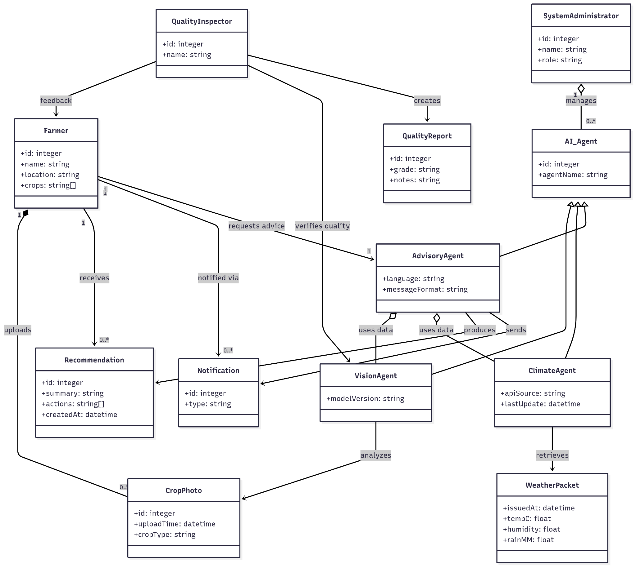

Sequence Diagrams
- User Registration
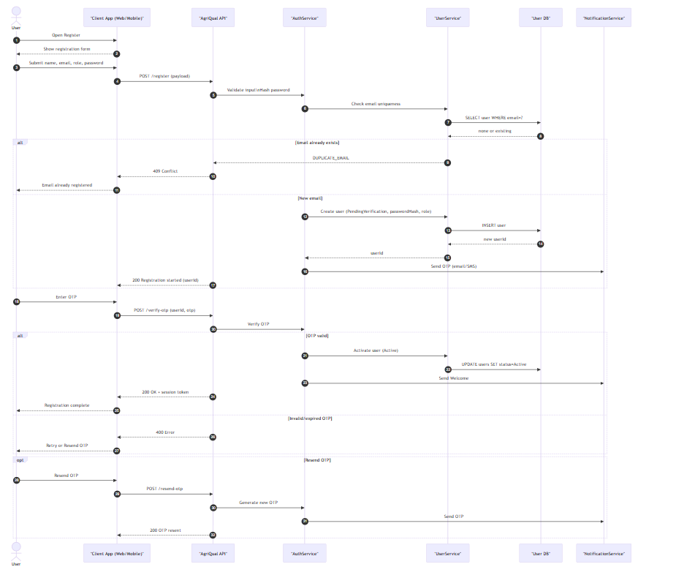
- Secure Login
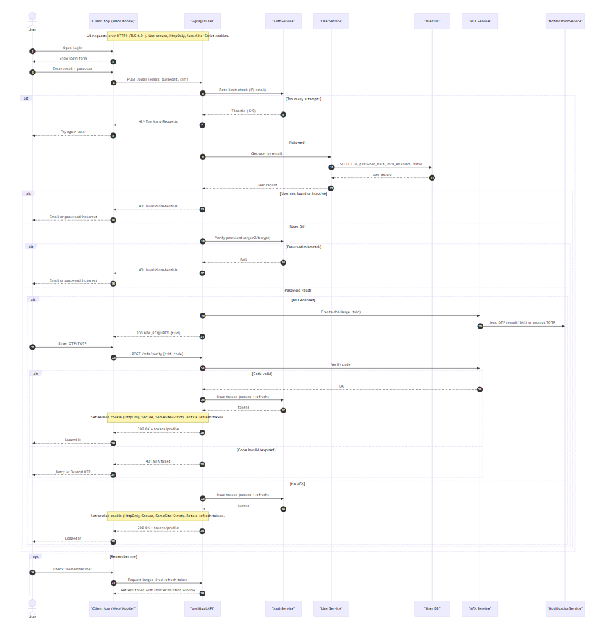

Upload Wheat Image for Diagnosis
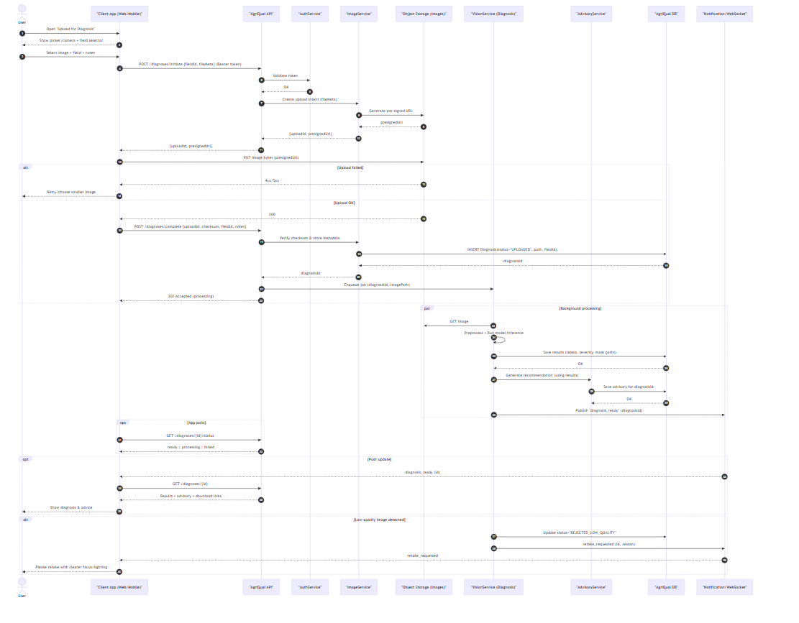

- Get Weather Aware Advisor
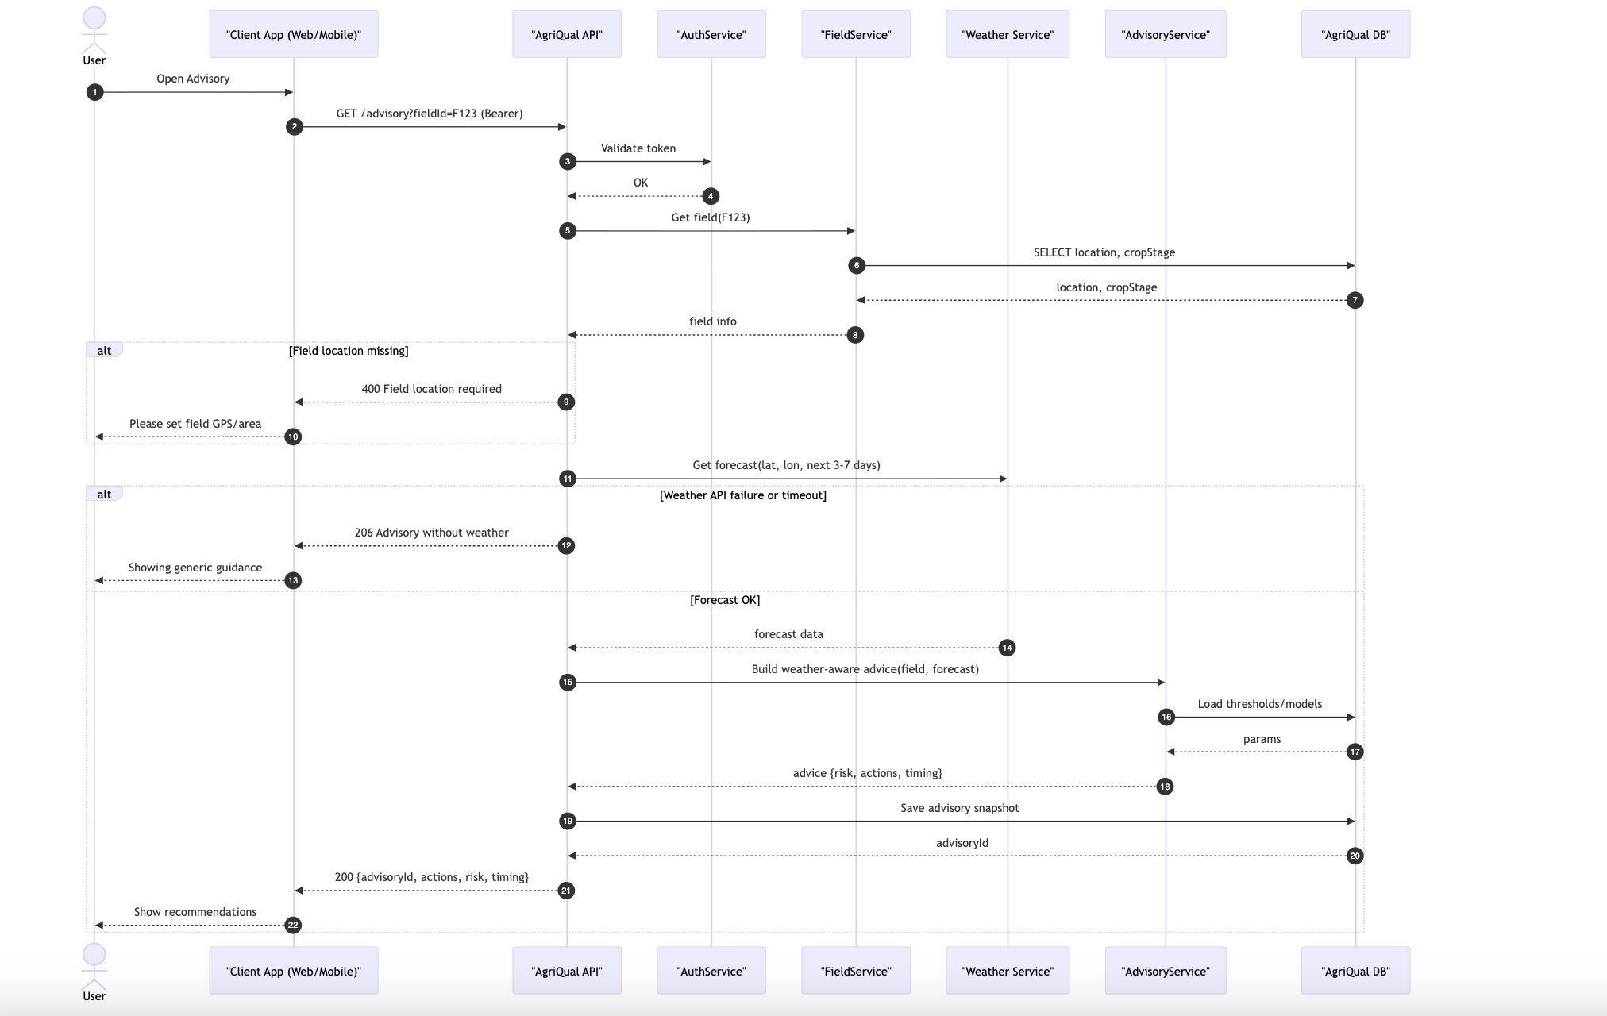

Manage Wheat Fields/Plots
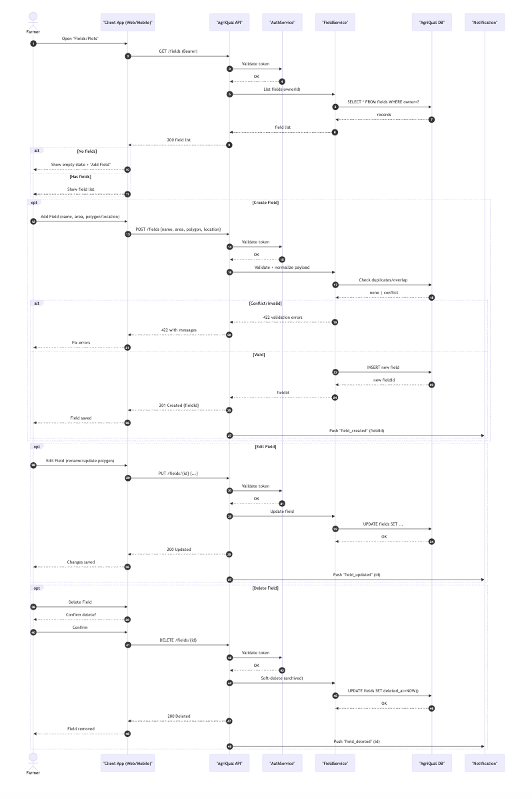
- View Diagnosis History
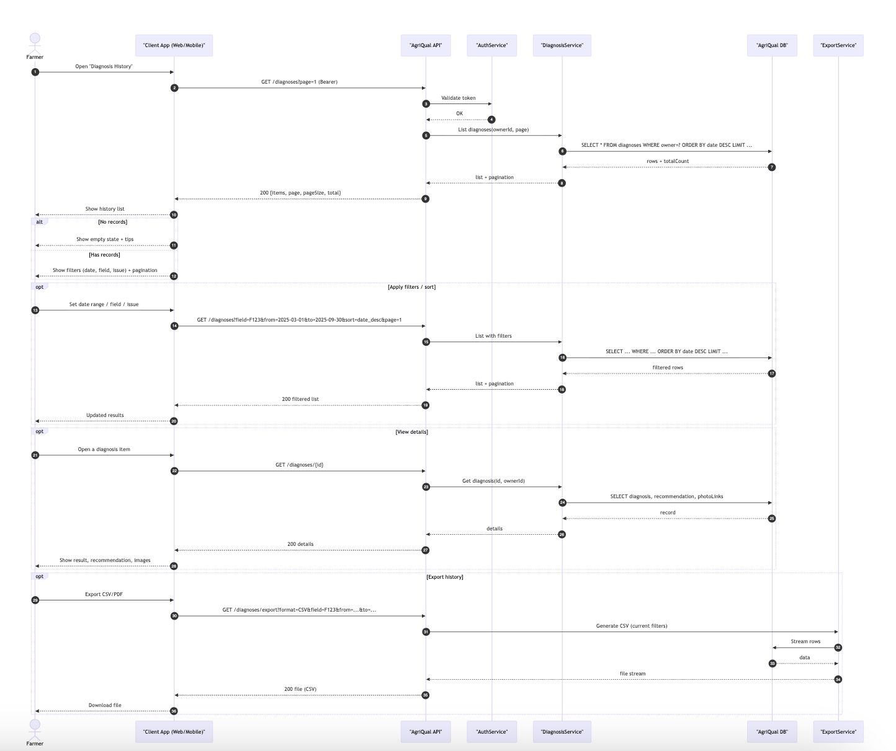

- Farmer Updates Wheat Field Information
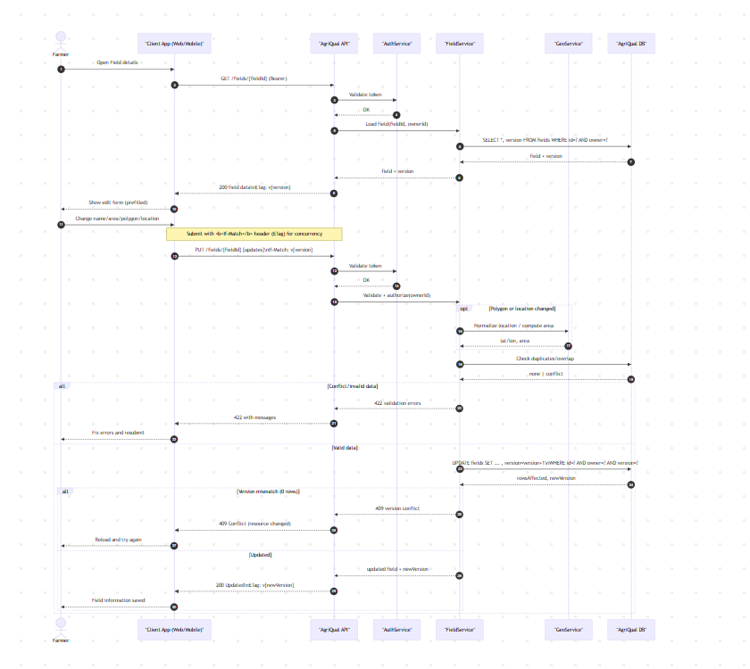

- Contact Support
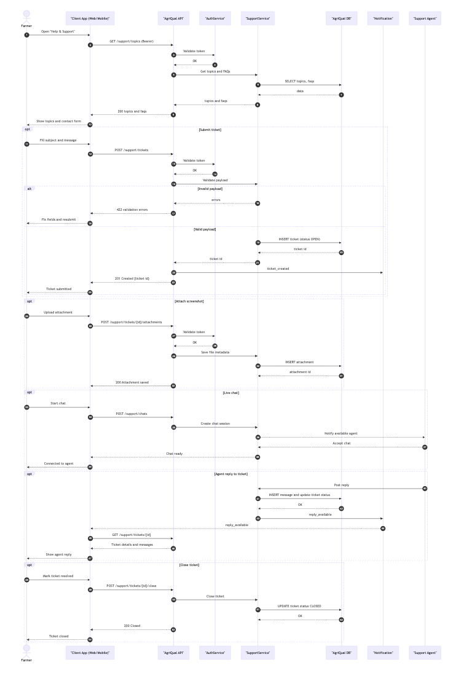

Receive Weather Alerts
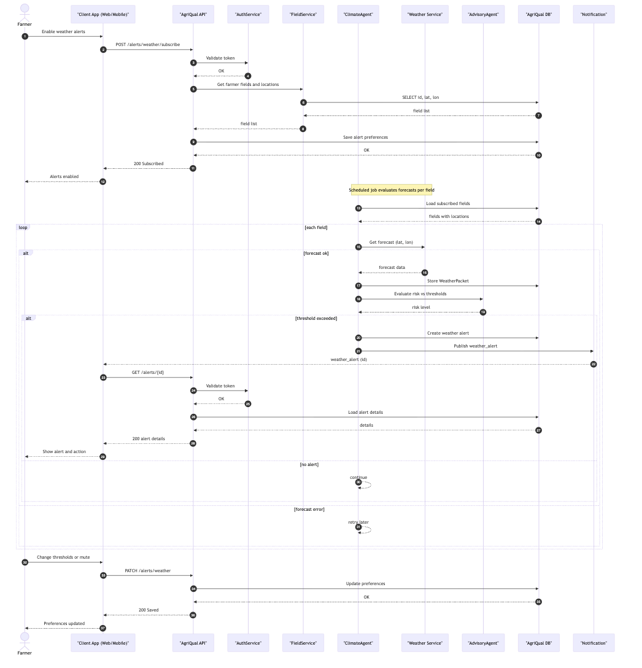

Generate Inspection Statistics
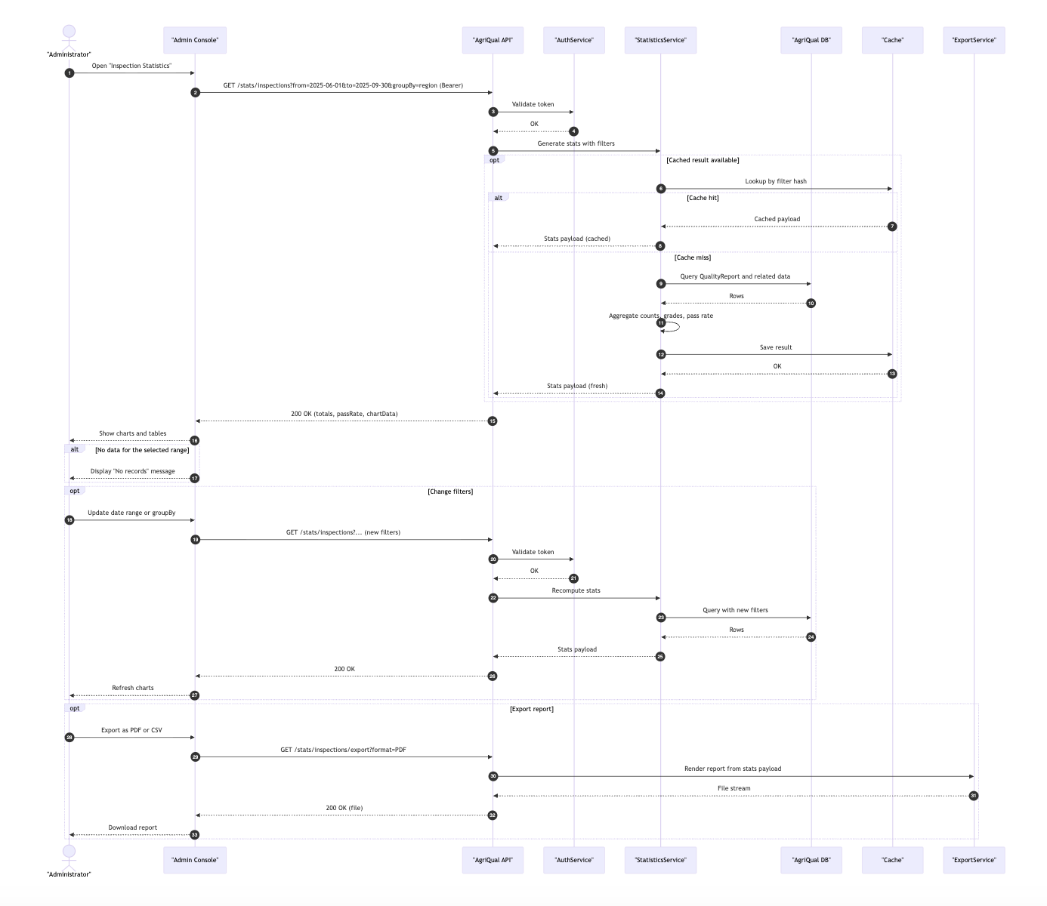

Software Development Methodology and Plan

This chapter describes the software development methodology adopted for the AgriQual projec, starting with, a comparison of the Waterfall and Agile (Scrum) development processes, followed by a justification for the methodology selected

Software Process Selection
Waterfall Model
The Waterfall model is a sequential, linear development process where each phase: requirements, design, implementation, testing, and deployment – must be fully completed before the next begins. Its main advantage is predictability: the scope, timeline, and deliverables are fixed upfront, making it easy to manage and document. It is particularly well-suited to projects with clearly defined and stable requirements. However, Waterfall is rigid and does not accommodate change well. If a requirement changes mid-project or a design flaw is discovered late, revisiting earlier phases is costly and time-consuming. For a project like AgriQual, where machine learning model behavior, UI/UX decisions, and integration challenges were not fully known at the outset, a purely Waterfall approach would have led to significant rework.
Agile (Scrum) Model
Agile is an iterative and incremental development methodology that breaks the project into short, time-boxed cycles called sprints. Each sprint delivers a working, tested slice of functionality, allowing the team to get early feedback and continuously refine the product. Its key advantages include flexibility to changing requirements, earlier detection of integration issues, regular visibility into progress, and the ability to prioritize the most valuable features first. The main challenge with Agile is that it requires strong team discipline and communication, and the final scope can be harder to estimate upfront. Despite this, Agile is widely recognized as the more appropriate choice for projects involving AI/ML components, novel integrations, and evolving user needs.
Justification
AgriQual was developed using the Agile (Scrum) methodology. The project was organized into two sprints, each divided into two phases of two weeks, giving a total of eight weeks of active development. GitHub Projects was used to manage the backlog, track tasks, and coordinate work across the four-member team. This approach was chosen for several reasons. First, AgriQual involved multiple uncertain technical components, including a PyTorch ML inference service, a RAG-based chat pipeline, real-time weather integration, and CI/CD deployment to Oracle Kubernetes Engine, whose exact behavior and integration complexity could not be fully anticipated from the start. Iterative development allowed the team to validate each component incrementally rather than discovering issues only at the end. Second, security analysis (STRIDE) and static code analysis (SonarQube) were embedded as dedicated sprint activities, ensuring that security was treated as a continuous concern rather than an afterthought. Third, the bilingual (English/Urdu) and multi-role (farmer, inspector, admin) nature of the product required ongoing UI refinement based on what was actually built. Agile provided the flexibility to address these concerns sprint by sprint.

Database Design and Web Services
AgriQual uses MongoDB as its database, with nine collections each implemented as a Mongoose model. The entity-relationship diagram is shown below, followed by a description of each collection.

Database Design
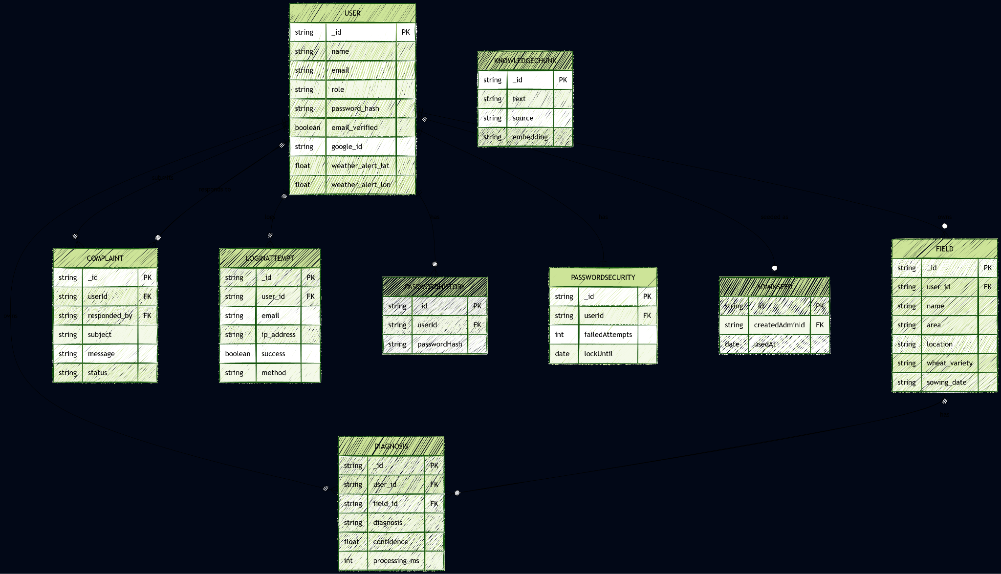
User
The central collection of the system. Stores all registered accounts regardless of role (farmer, inspector, admin). Key fields include the bcrypt-hashed password, email verification status, a hashed OTP for registration, account lockout tracking (failed login attempts and lock expiry), an optional Google OAuth ID for social login, and latitude/longitude coordinates used to target weather alert emails.
Field
Represents a farmer’s registered wheat plot. References the owning User and stores descriptive metadata: field name, area, location, wheat variety, and sowing date. Fields can be linked to individual diagnoses, enabling health score tracking per plot.
Diagnosis
Stores the result of each crop image scan. References the User who submitted it and optionally the Field it belongs to. Contains the top predicted disease label, its confidence score, an embedded array of runner-up predictions with their confidences, treatment recommendations, and the ML inference time in milliseconds (used for SLA monitoring).
Complaint
Records support tickets submitted by farmers or inspectors. References the submitting User and, once resolved, the admin User who responded. Tracks ticket subject, message body, admin reply text, response timestamp, and a status field (not addressed or addressed).
LoginAttempt
Audit log for every login event, successful or failed. Stores the email used, the resolved User reference if found, the client IP address, browser user-agent, outcome, failure reason, and the authentication method used (password or Google OAuth).
PasswordHistory
Stores the bcrypt hashes of a user’s previous passwords to prevent reuse. Each document references the User and records when that password was set. The system retains the last five entries per user and rejects any new password that matches a stored hash.
PasswordSecurity
A one-to-one extension of User that tracks the lockout state specifically for the password-change flow, separate from the login lockout tracked on the User document itself. Stores the count of consecutive failed change attempts, the lockout expiry timestamp, and the time of the last attempt.
KnowledgeChunk
The vector store for the RAG-powered chat feature. Each document holds a text slice extracted from an agricultural PDF, the source document name, optional topic tags, and a high-dimensional embedding array generated by OpenAI’s text-embedding-3-small model. At query time, the user’s question is embedded and the top matching chunks are retrieved via cosine similarity search in JavaScript, then injected into the GPT prompt as context. This collection has no foreign key relationships to other collections.
AdminSeed
A single-document audit record created when the one-time admin bootstrap endpoint is called. Stores the timestamp of the seed operation and a reference to the admin User account that was created. This prevents the endpoint from being called more than once in a deployment.

API Specification
AgriQual integrates four external third-party APIs. The table below lists each one, its purpose in the system, and the specific endpoint or model used.

API / Service | Version / Model | Purpose in AgriQual | Endpoint / Notes
Open-Meteo | v1 (free, no key) | Fetches current conditions, hourly forecasts, and daily summaries (temperature, precipitation, UV index, wind gusts) for the weather dashboard and the background weather alert scheduler. | api.open-meteo.com/v1/forecast
OpenAI API (Chat) | gpt-4.1-mini | Powers the RAG-based advisory chatbot. Receives the user’s question, retrieved knowledge chunks, and the current diagnosis as context, and returns a grounded, cited response with a recommendation to consult an agronomist. | api.openai.com/v1/chat/completions
OpenAI API (Embeddings) | text-embedding-3-small | Generates vector embeddings used in two places: at ingestion time to embed agricultural PDF chunks into the KnowledgeChunk collection, and at query time to embed the user’s chat question for cosine similarity retrieval. | api.openai.com/v1/embeddings
Resend | Resend SDK (v1) | Handles all outbound email in the system: OTP delivery during registration, weather alert notifications to farmers, admin SLA breach alerts, complaint responses, and broadcast emails sent from the admin dashboard. | api.resend.com/emails (via SDK)
Google OAuth2 | google-auth-library v9 | Enables one-tap Google Sign-In for farmers and inspectors. The backend verifies the Google ID token server-side using the OAuth2Client, extracts the verified email and Google subject ID, and creates or looks up the corresponding User record. Admin accounts are explicitly blocked from using this flow. | oauth2.googleapis.com/tokeninfo (server-side verification)

System User Interface

What people actually see
AgriQual is a web app: one screen at a time, in the browser, with a calm green-and-cream look that stays the same whether you are on a phone or a laptop. We built the front end in React, so the page does not fully reload when you move between tasks so it feels like a small app, not a stack of separate websites.A nice detail for Pakistani users is that you can flip between English and Urdu. Labels and the main guidance text follow that choice, and Urdu uses right-to-left layout where it matters, so the interface still reads comfortably.After you log in, you only see what matches your role: farmers get the farming hub, inspectors get an inspection-oriented workspace, and admins get a separate console. That keeps the noise down so nobody has to hunt through menus that were never meant for them.

Signing in and creating an account
First-time users hit Register. They fill in their name, email, optional phone, a password (twice, so typos do not slip through), and whether they are signing up as a Farmer or an Inspector. If email verification is turned on, they get a code and land on a small OTP screen to finish setup.Returning users use Login: email, password, and the same green “sign in” feel. There is a Forgot password link.

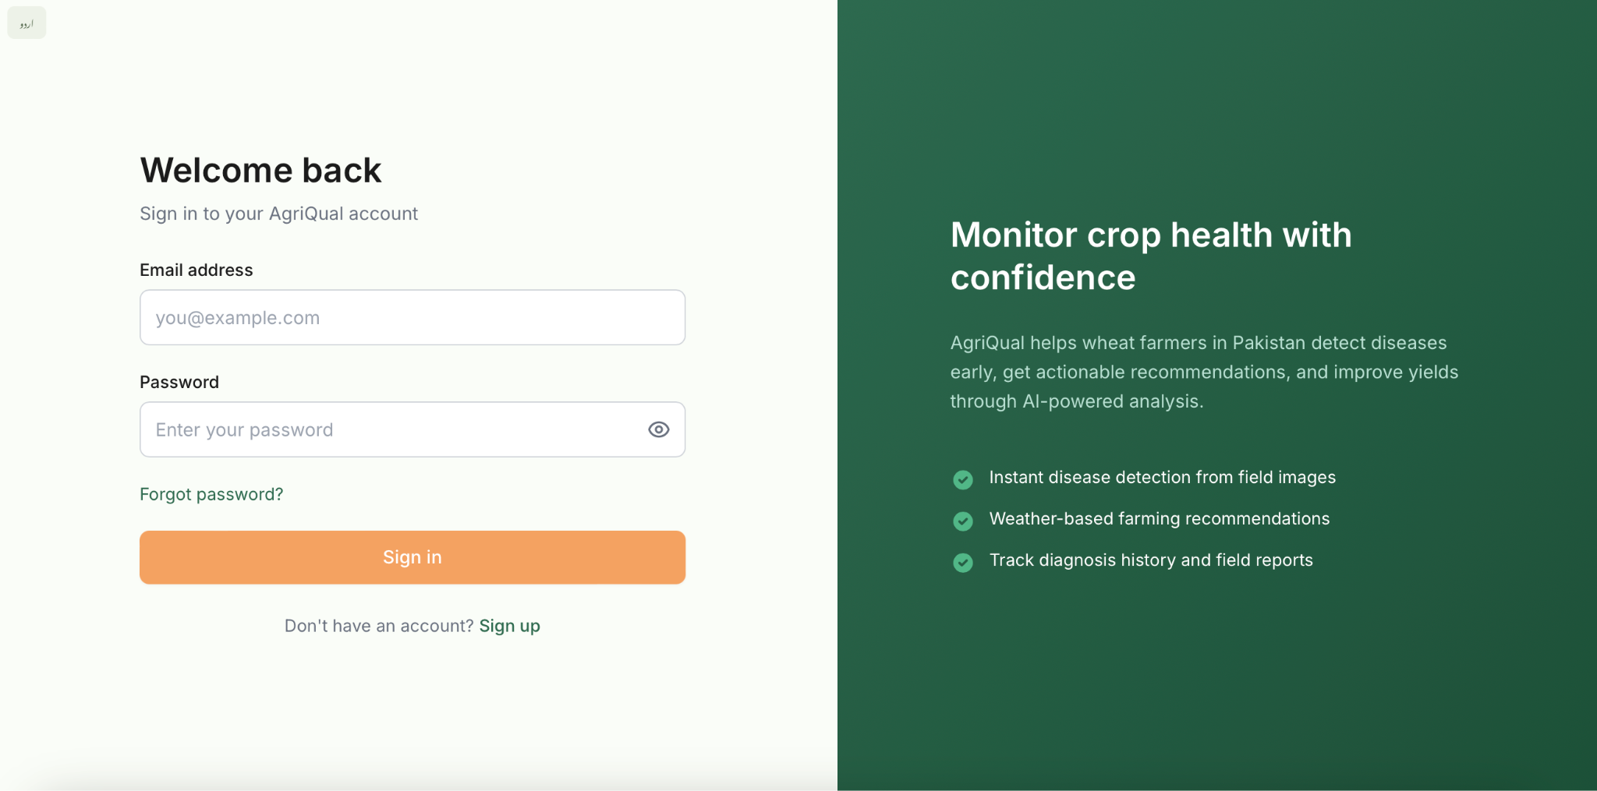
Figure 1 — Login

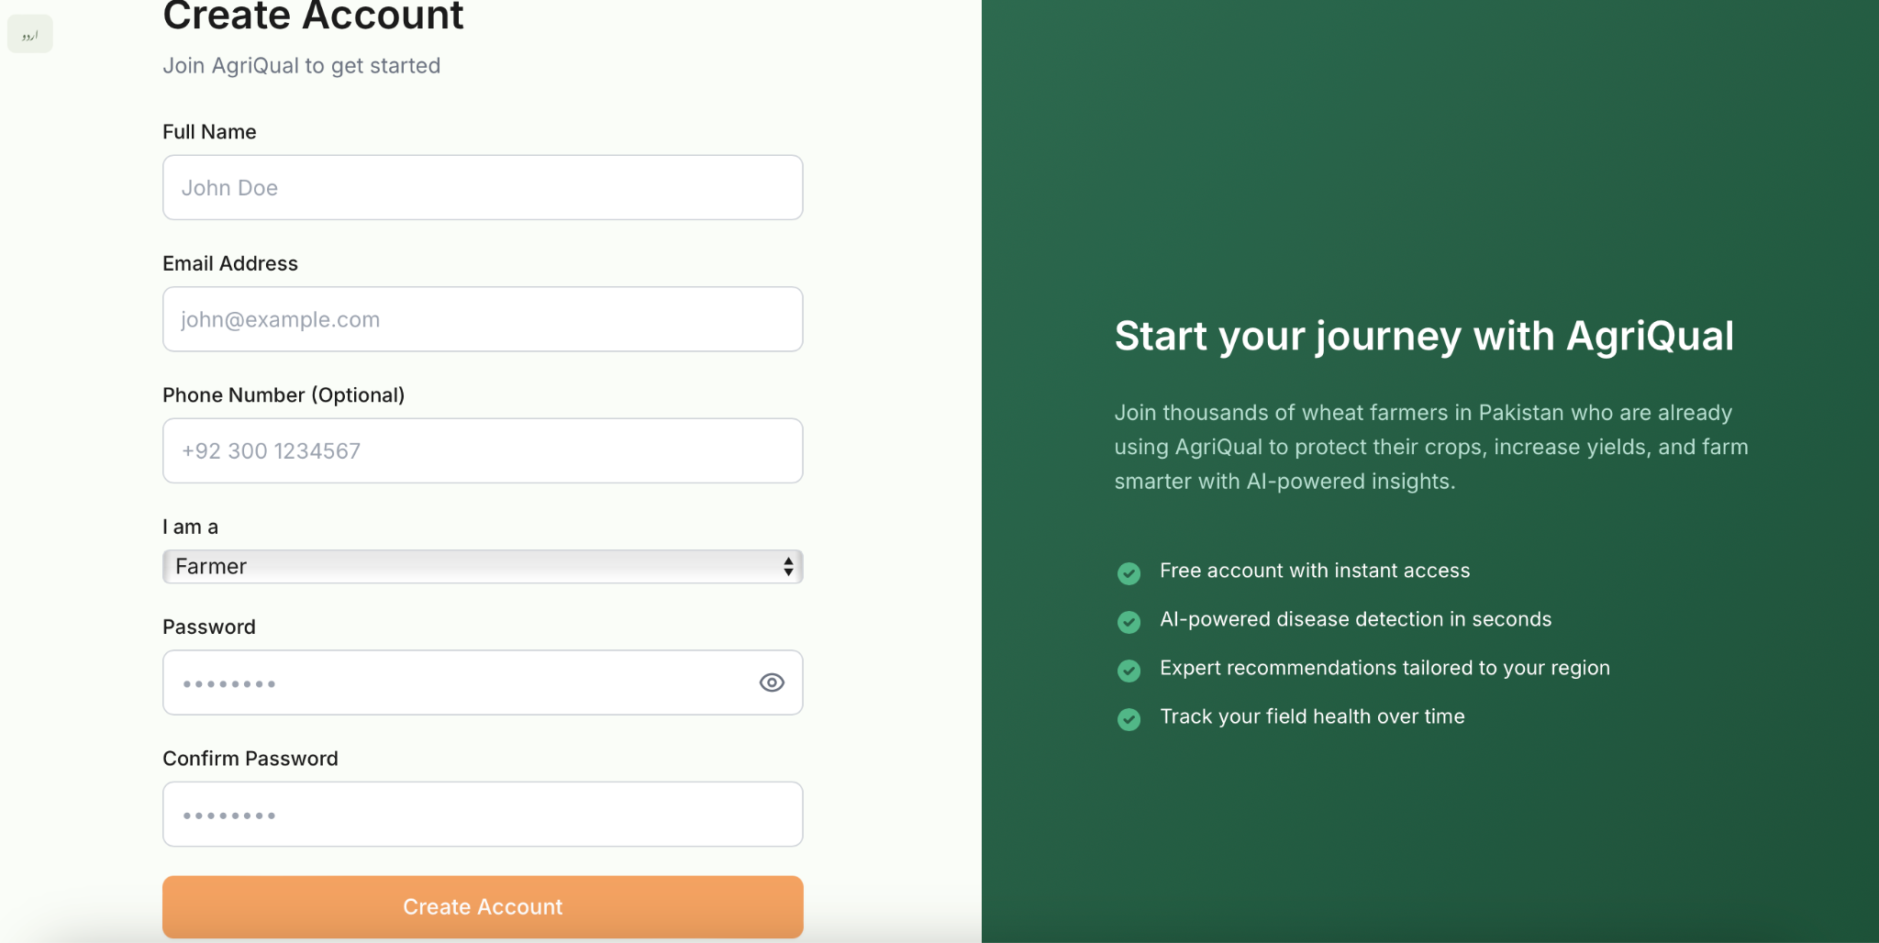
Figure 2 — Sign Up

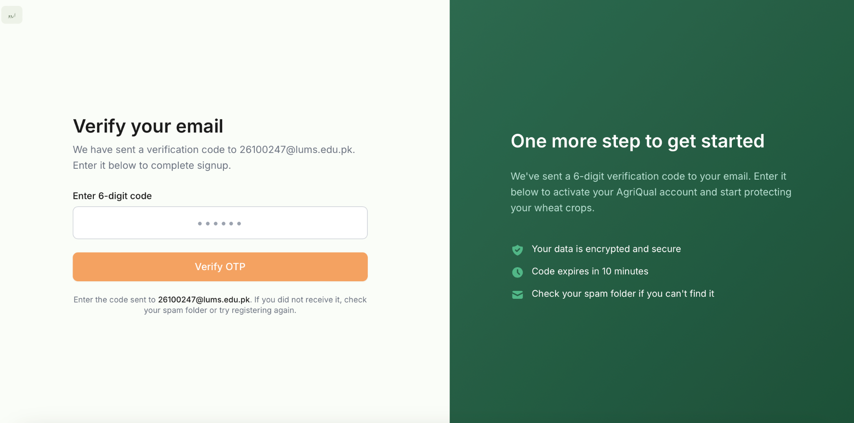
Figure 3 — OTP

For farmers: the day-to-day screen
The Farmer Dashboard is the heart of the prototype. Think of it as a single place to answer: What is the weather doing? Is my wheat okay? Which plot did this scan belong to?Weather that is with location permission (or saved coordinates), the app pulls a forecast and turns it into short, practical lines: rain vs irrigation, wind vs spraying, that sort of thing. It is meant for decisions on the ground, not a meteorology lecture.Crop scan — Farmers pick or snap a photo of wheat. They see a preview, send it off, and get back a diagnosis, a confidence readout, and recommendations. There is also a chat panel so they can ask follow-ups in plain language with the latest result in context. Fields: My Fields is where plots live: name, area, variety. They can add, edit, or remove entries. When a scan is tied to a field, the dashboard can reflect that link so history stays tied to real land.History: A dedicated Diagnosis History page lists past scans newest first. Opening an entry shows the label, confidence (with colour cues), recommendations, and any linked field which is useful. Extras:From the same dashboard they can file help / complaints, change password, open profile and logout.
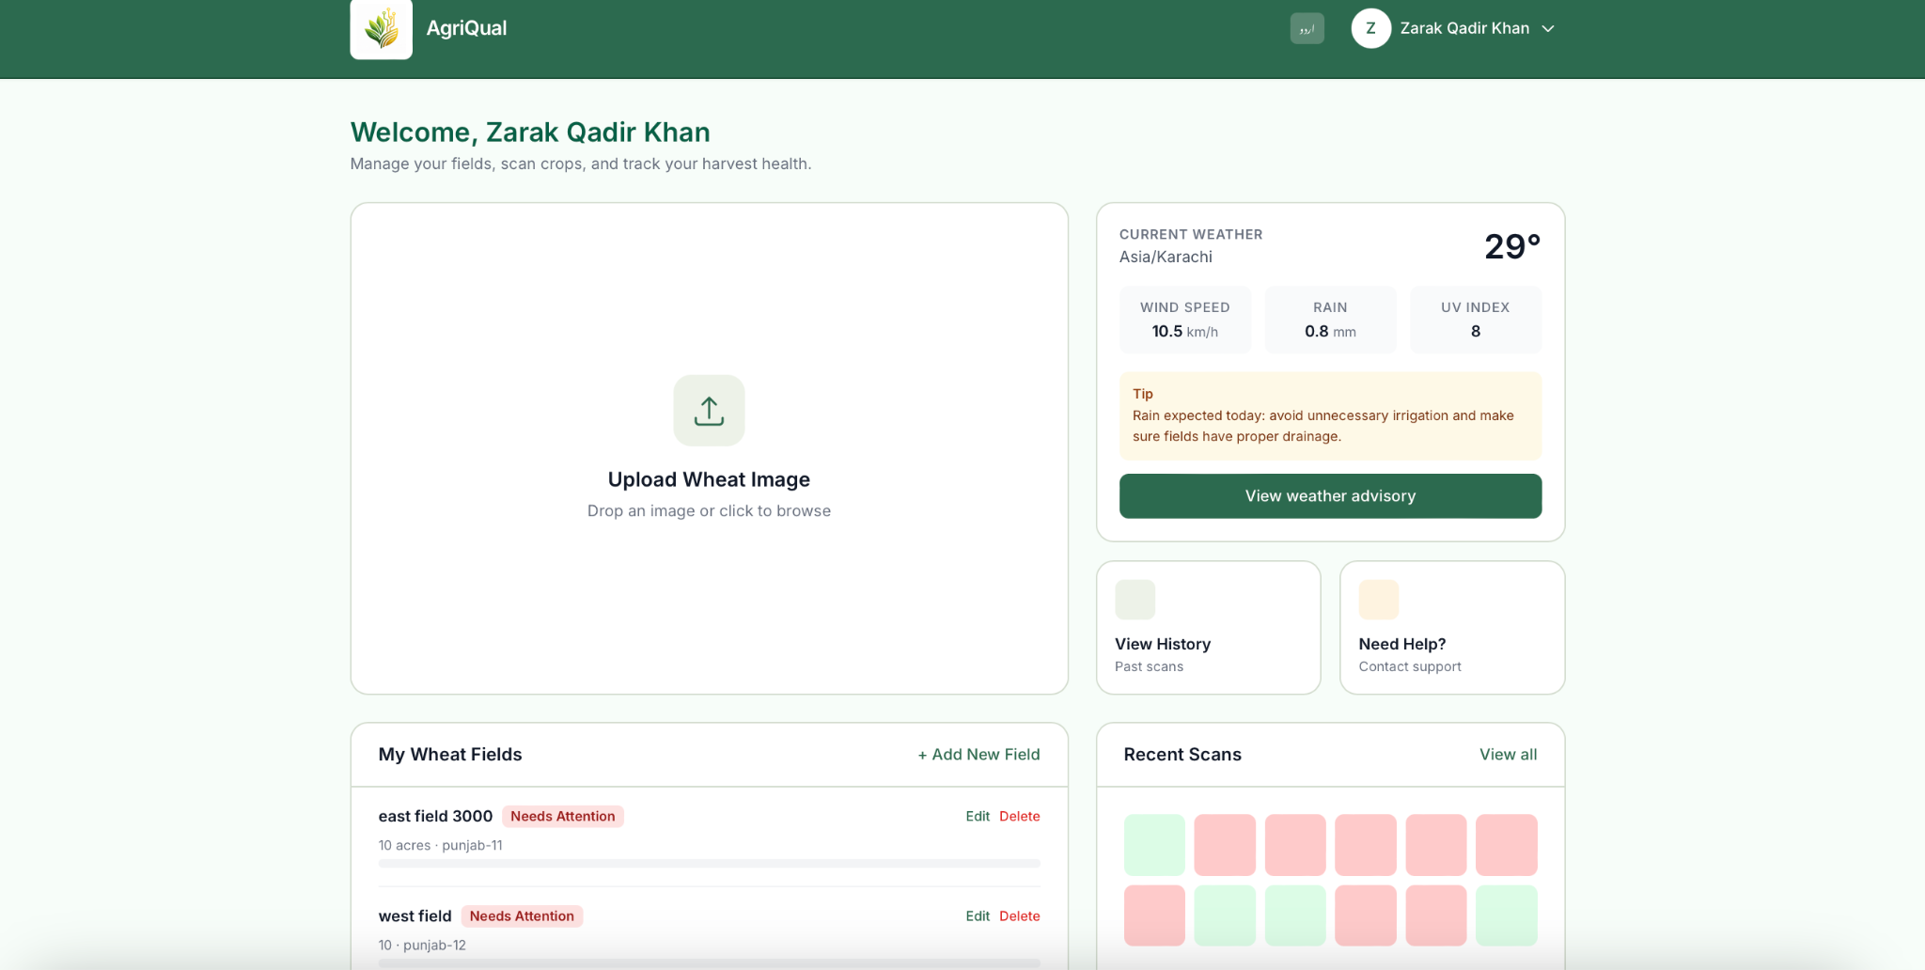
Figure 4 — Farmer dashboard

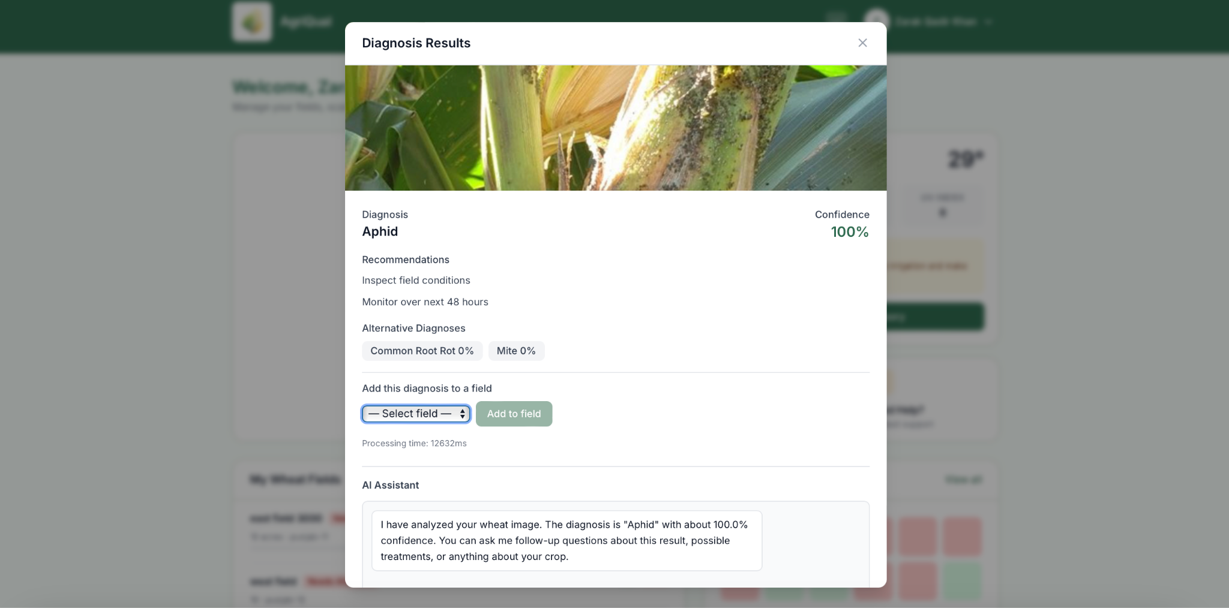
Figure 5 — After a scan

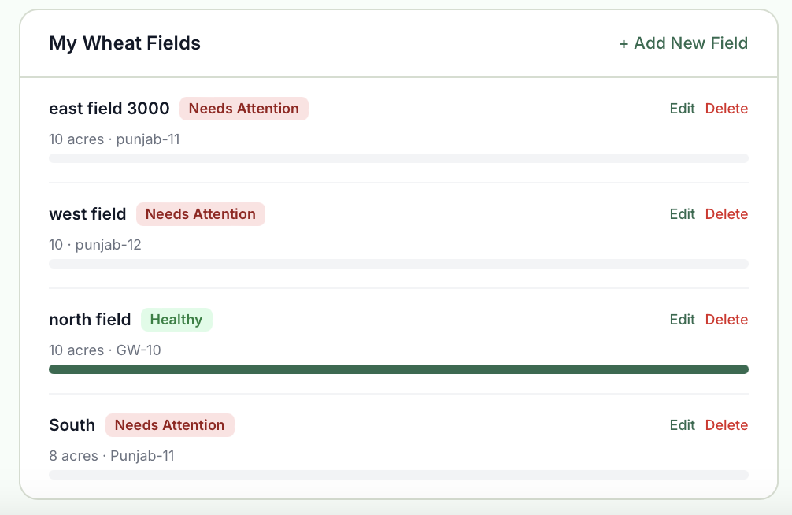
Figure 6 — Managing fields

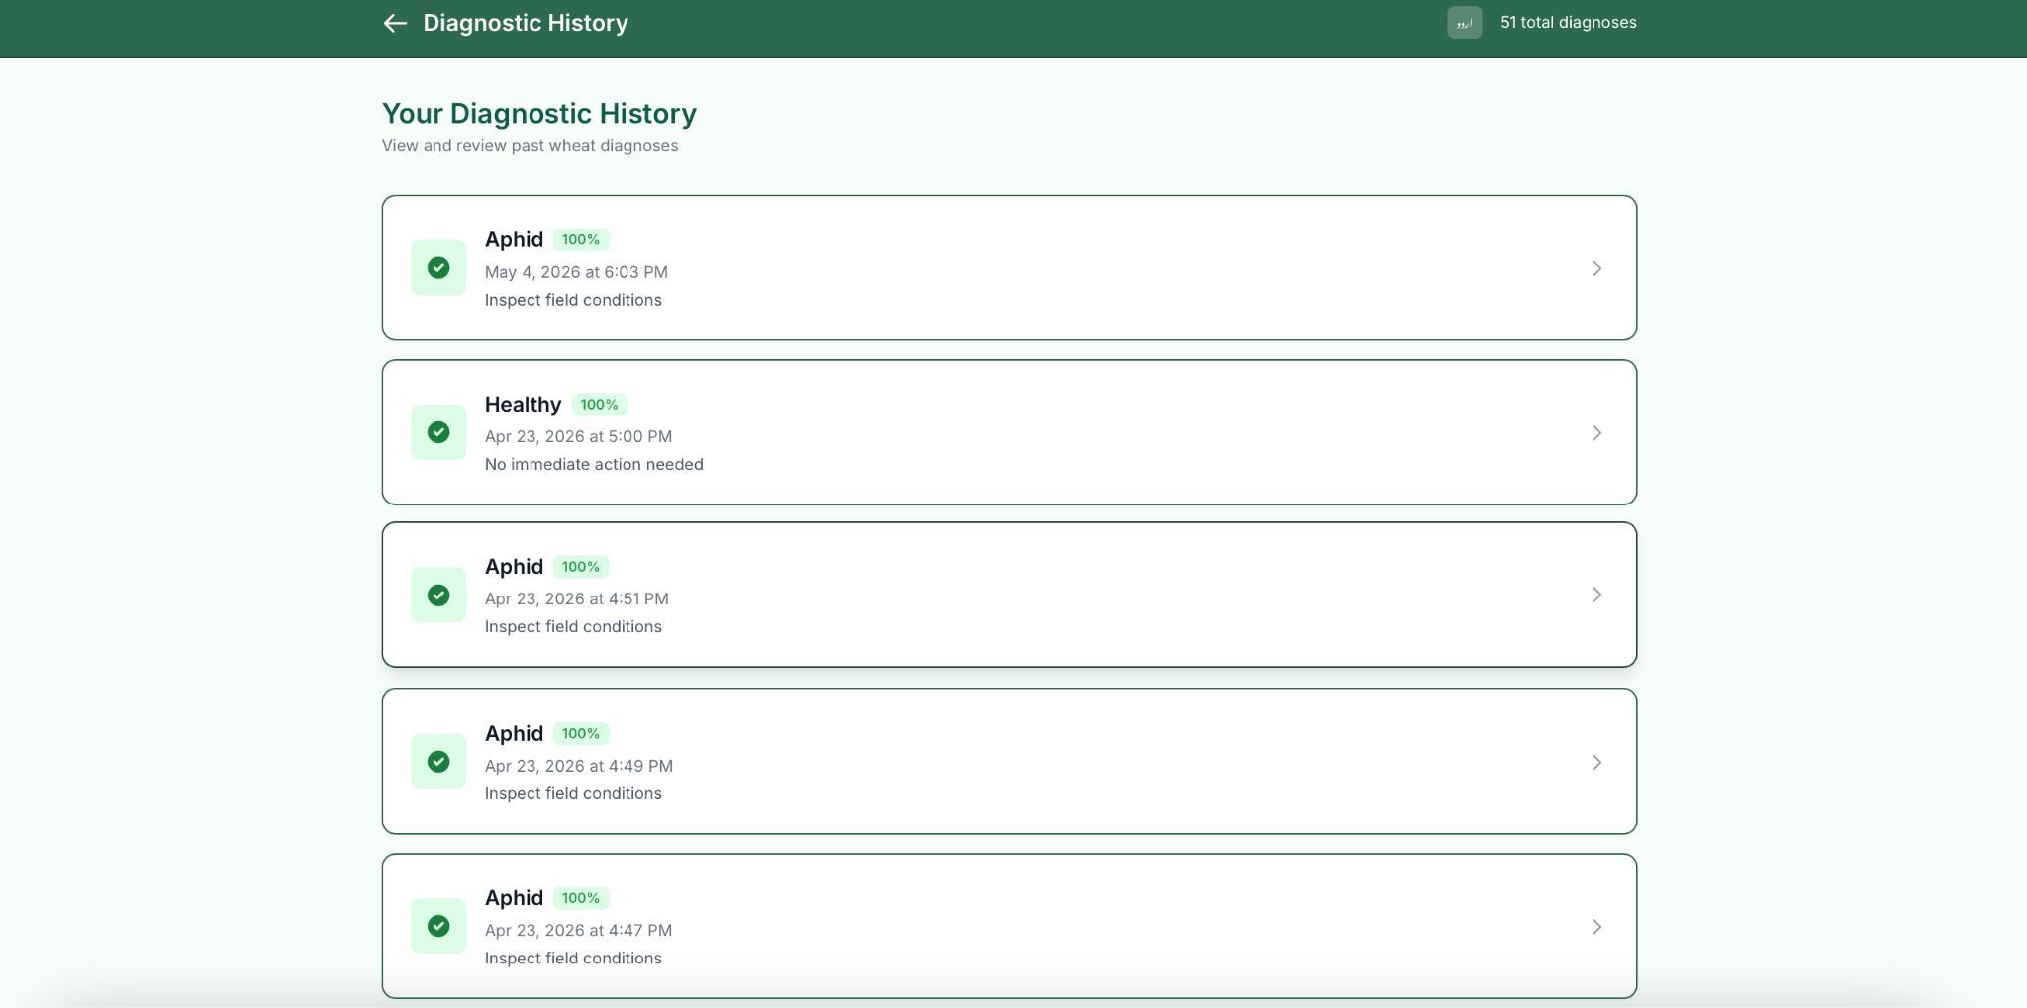
Figure 7 — History

For administrators
Admins get a different layout: a console built around running the service, not farming day-to-day. They can work through complaints, send broadcast or targeted email, help with farmer password reset, and open charts for inspection activity and SLA-style timing on diagnoses so the team can see whether the prototype feels fast enough in real use.
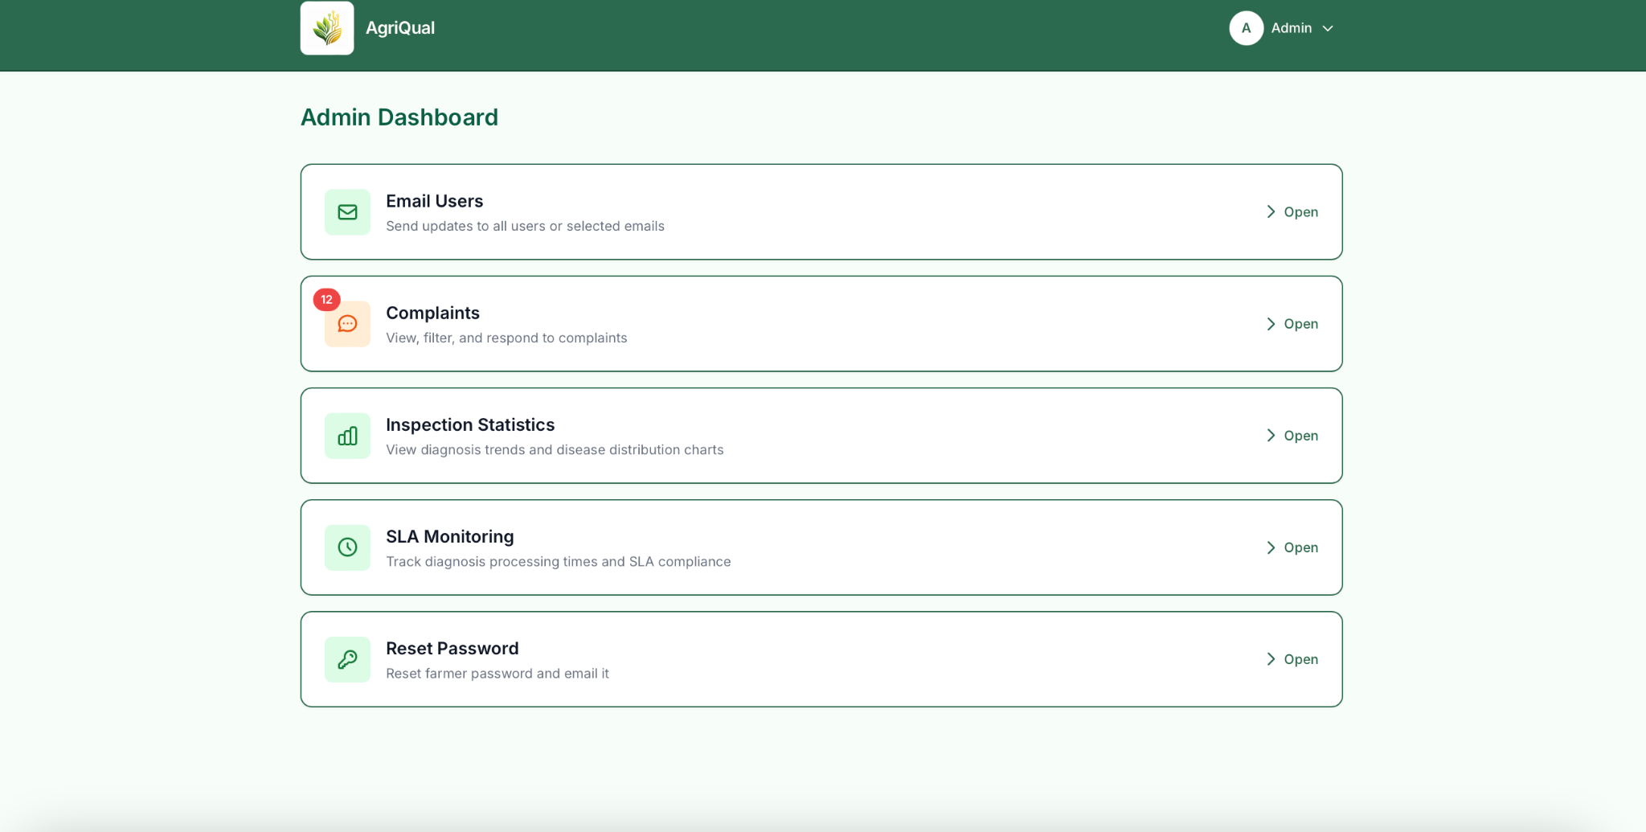
Figure 9 — Admin console

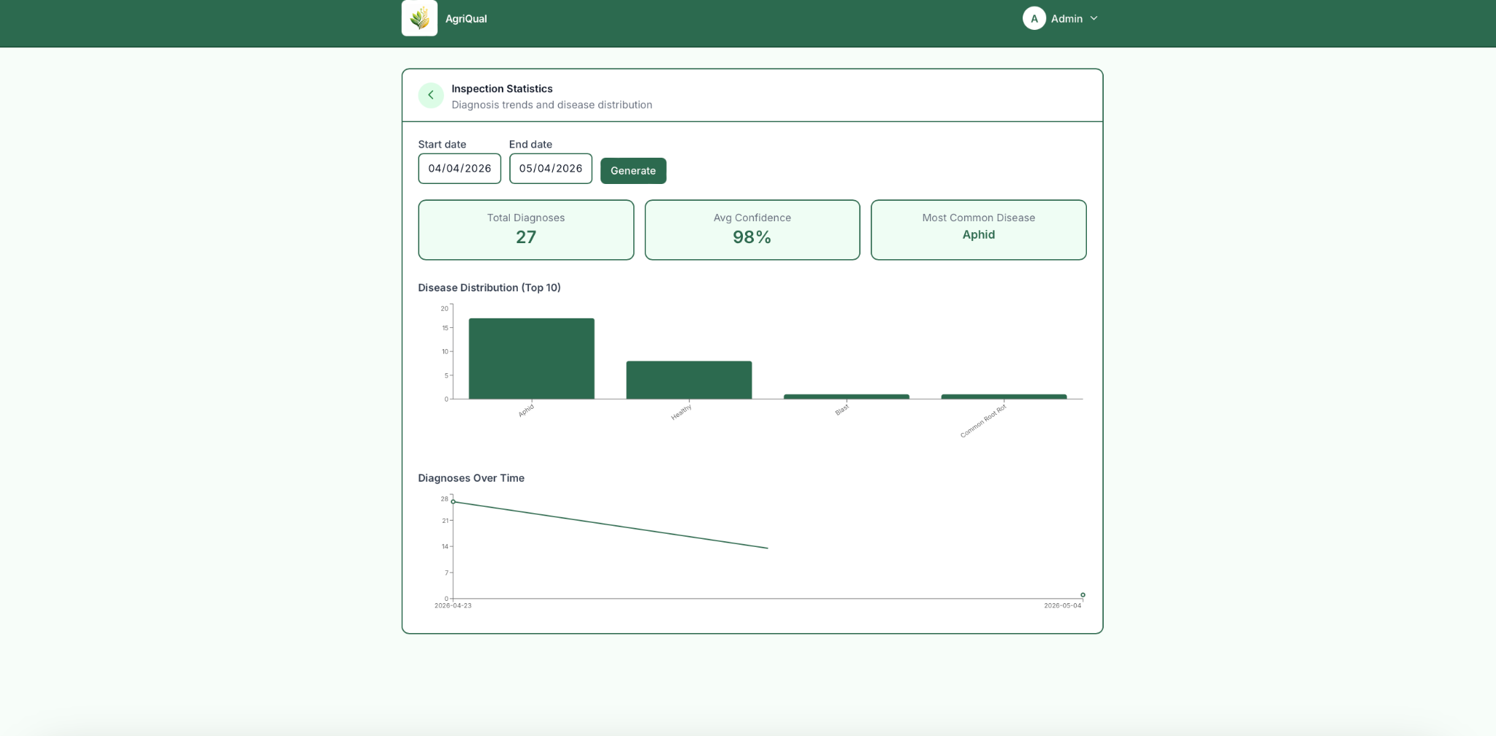
Figure 10 — Inspection Statistics

Why we designed it this way
We wanted non-technical users to get through common tasks without hunting—weather, scan, and fields stay close to the top. Errors and “still loading” states appear on the same screen so people are not left wondering if anything happened. And because many users will open this on a phone in a field, the layout is responsive: it should remain readable on a small screen, not only on a desktop demo.

Project Security

How we think about security
Security for AgriQual is not a single feature, it is a thread that runs through who can sign in, what each role is allowed to do, how we call other services, and how we catch weak spots in code before they ship. Our course deliverable on STRIDE-based threat modelling is the written record of that thinking: for the use cases we built in each sprint, we worked through Spoofing, Tampering, Repudiation, Information disclosure, Denial of service, and Elevation of privilege and wrote down threats plus the controls we rely on (JWT verification, bcrypt, rate limits, server-side RBAC, logging, and so on). What follows is the distilled version that belongs in the main project document; the full sprint-by-sprint tables stay in the dedicated STRIDE submission.

STRIDE in practice (what we actually mitigate)
Spoofing: We care about people pretending to be someone else. Password-based login uses validated credentials and bcrypt hashing.
Tampering : Clients might send edited JWTs or bodies. Tampered JWTs fail verification and get 401. Role-sensitive actions use requireAuth and requireRole on the API; the frontend route guards are for usability only,the API remains the real boundary. Payloads for critical flows are validated on the server (email format, password rules, file types for uploads).
Repudiation: Where it matters, we leave an audit trail: LoginAttempt records (success/failure, IP, user-agent, reason). RBAC denials can be logged server-side when access is forbidden, so “who tried what” can be reviewed later without exposing internals to the client.
Information disclosure: We avoid leaking secrets in responses (no raw tokens in generic user payloads beyond what login must return). Generic error messages on auth failures reduce account enumeration. JWT_SECRET and provider keys are environment variables, not hardcoded for production. Logs should not print full OTPs in normal operation.
Denial of service: Rate limiting applies to sensitive endpoints (for example diagnosis uploads). File uploads are size- and type-limited. These controls mirror what we wrote under DoS-style threats in the STRIDE document (flooding login, diagnosis, or support channels).
Elevation of privilege: We treat this as the highest risk for a multi-role app. Admin is not created through normal registration or Google path; a separate seed flow with a configured secret is used once. Backend checks role on protected routes; claiming “admin” in the UI does not grant API access without a valid token and matching server-side role.

Static analysis: SonarCloud
Alongside threat modelling, we use SonarCloud (hosted SonarQube) so every push does not only rely on human review. A dedicated workflow .github/workflows/sonar.yml runs on push and pull requests to main, and can be triggered manually (workflow_dispatch). It checks out the repo with full history (fetch-depth: 0, which Sonar recommends for blame-related analysis), sets up Node 20, installs dependencies under P08-Agri/Prototype/code, runs npm test -- --ci as part of the pipeline, and then executes the official sonarsource/sonarqube-scan-action@v6 against https://sonarcloud.io. Authentication uses a SONAR_TOKEN stored in GitHub Actions secrets—the token never lives in the repository.sonar-project.properties at the repo root tells Sonar which codebase to analyze: sonar.sources=P08-Agri/Prototype/code, with exclusions for node_modules, dist, and build, and sonar.scm.disabled=true where SCM integration is configured that way for the project. The SonarCloud project is SPROJ-P08 under the linked organization, matching the key and name in that file.In plain terms: SonarCloud scans our prototype source tree on each qualifying workflow run, surfaces bugs, vulnerabilities, code smells, and coverage-related signals (depending on what SonarCloud is configured to enforce for the project), and gives the team a single dashboard to prioritize fixes. It complements STRIDE by catching implementation-level issues; STRIDE complements Sonar by explaining why controls exist for each use case.

What STRIDE + Sonar do not replace
Threat modelling and SonarCloud do not replace a full penetration test, TLS configuration on the live host, secret rotation, or dependency auditing; those stay part of good deployment hygiene. For this course prototype, the combination we document is: STRIDE for structured threat thinking, implemented controls in the Node/React stack, and SonarCloud for continuous static analysis tied to GitHub.

Risk Management

Potential Risks and Mitigation Strategies

Sr. | Risk Description | Mitigation Strategy
1. | Staff turnover  Experienced staff leaves the project before it is finished. | Maintain detailed project documentation and version control (GitHub) for all modules. Use clear coding standards and frequent knowledge-sharing sessions so that onboarding new members is smooth. Assign backup owners for each module (AI, backend, advisory).
2. | Requirements change  Changes in requirements that require major design rework are proposed. | Use agile development with iterative sprints. Maintain a clear change management process with stakeholder approval. Keep architecture modular so components (e.g., VisionAgent, AdvisoryAgent) can be updated independently.
3. | Underestimation  The size of the system is underestimated. | Include buffer time in each sprint and review project milestones regularly. Use early prototyping to validate complexity. Conduct weekly reviews with advisors and stakeholders.
4. | Technology change  The underlying technology on which the system is built is superseded by a new technology. | Use widely supported frameworks and APIs. Abstract AI agents (VisionAgent, ClimateAgent) behind interfaces to allow model updates. Monitor ML and API versions for compatibility.
5. | Code generation  The code generated by generative AI is inefficient. | Review AI-generated code manually before integration. Use code linting, testing pipelines, and peer review. Train AI tools with project context for higher-quality outputs.
6. | Data  Required data is not available. The required data may be for training of ML Model or for some other purpose. | Build partnerships with agricultural research institutions for dataset access. Use synthetic data generation for missing samples. Maintain data validation scripts and fallback datasets.
7. | Stakeholder management  Customers fail to understand the impact of requirements change. | Conduct regular stakeholder demos and collect feedback. Provide UI mockups and early prototypes. Keep a communication log and maintain simplified documentation for non-technical users.
8. | Off the shelf components and libraries  Software components/libraries that were planned to be used do not contain desired features or contain defects, i.e., they cannot be used as planned. | Evaluate and test all dependencies early. Keep alternative libraries and versions documented. Use Docker or virtual environments to isolate dependencies and avoid conflicts.
9. | Security & Privacy Risk:Sensitive user data (e.g., farm data, images, location) may be exposed or misused. | Implement secure authentication and authorization mechanisms. Encrypt data in transit and at rest. Follow best practices for API security. Regularly audit the system for vulnerabilities and ensure compliance with data protection standards.
10. | Model Accuracy & Bias Risk:  AI models may produce incorrect or biased recommendations due to limited or skewed training data. | Continuously retrain models with diverse and updated datasets. Validate outputs with agricultural experts. Implement confidence scoring and allow human override (e.g., advisory agent review). Monitor model performance and user feedback regularly.

Testing and Evaluation
Our testing strategy was to keep coverage practical for a prototype:1) verify the critical user journeys end-to-end in the browser,2) add a light unit smoke check for app boot/routing,3) run checks automatically in CI, and4) include focused checks for AI-powered flows (diagnosis output, confidence, weather-advisory behavior, and SLA expectations) based on the STRIDE + architecture documents.

1) Testing strategy we followed
- Risk-based focus: We prioritized features that can break user trust quickly (login, role routing, session/logout, language switching, diagnosis result flow).
- Layered approach:
- E2E/UI tests for user behavior in real browser conditions.
- Unit smoke test for app default render behavior.
- Static analysis for code quality/security smells before merge/deploy.
- Security-aware scenarios (from STRIDE): Login failures, role-bound access, session handling, and error messaging were explicitly tested.
- AI flow validation: We validated that AI-facing screens consume and display key fields correctly (diagnosis label, confidence), and we defined SLA/edge-case checks from your uploaded AI/security docs.

2) Sample test cases

A) Functional + UI test cases (implemented)
Test ID | Test case | Expected result | Status
TC-UI-01 | Visit / as unauthenticated user | Redirects to /login | Implemented (smoke.cy.js)
TC-UI-02 | Open login page | Email and password fields visible | Implemented (smoke.cy.js)
TC-UI-03 | Navigate login → register | “Sign up” link opens /register | Implemented (smoke.cy.js)
TC-AUTH-01 | Mock login as farmer | Redirects to /farmer-dashboard, farmer name visible | Implemented (login.cy.js)
TC-RBAC-01 | Mock login as inspector | Redirects to /inspector-dashboard | Implemented (roles.cy.js)
TC-RBAC-02 | Mock login as admin | Redirects to /admin-dashboard | Implemented (roles.cy.js)
TC-AUTH-ERR-01 | Login API returns 401 + message | UI shows “Invalid email or password” | Implemented (auth-errors.cy.js)
TC-SESSION-01 | Logout from farmer/admin dashboard | Returns to /login, token cleared | Implemented (session.cy.js)
TC-I18N-01 | Toggle login page English ↔ Urdu | Copy switches correctly both directions | Implemented (language.cy.js)
TC-UNIT-01 | Render app with no session | Login screen is default view | Implemented (App.test.js)

B) AI-related test cases

Test ID | AI test case | Expected result | Current state
TC-AI-01 | Upload valid wheat image (JPG/PNG) to diagnose | API returns diagnosis + confidence; UI renders both | Implemented in product flow; should be part of regression checks
TC-AI-02 | Upload invalid type/oversize image | Request rejected with clear validation error | Backend validation exists (diagnose.js)
TC-AI-03 | Low-confidence prediction scenario | Confidence shown clearly; user can review details/history | Aligned with architecture requirement
TC-AI-04 | ML service unavailable/timeout | User gets graceful error (no crash) | Backend fallback/error handling exists
TC-AI-05 | SLA check for diagnosis (target: <= 15s) | Normal requests complete within threshold; breach is logged/alerted | Prototype includes breach alert behavior
TC-AI-06 | Weather advisory response-time check (target: <= 30s) | Advisory arrives with weather + tips or graceful fallback | Design + route logic support this; validate in test runs
TC-AI-07 | Prompt/advisory safety check (chat/advice output) | No unsafe/system-leaking content, no role escalation hints | Security/threat-model driven manual review
TC-AI-08 | Adversarial/noisy image | System returns controlled response, does not crash | Recommended evaluation case from AI reliability angle

3) Automation tools used
- Cypress
- Main UI/E2E automation framework.
- Covers login, role routing, session/logout, language toggle, and auth-error handling.
- Jest + React Testing Library
- Lightweight unit/smoke testing (App.test.js) for basic render/routing confidence.
- GitHub Actions
- frontend-e2e.yml: runs Cypress in CI on frontend-related pushes/PRs.
- sonar.yml: runs tests + Sonar scan on push/PR to main.
- SonarCloud (SonarQube cloud)
- Static analysis for maintainability/security/code smells on P08-Agri/Prototype/code.
- npm scripts / start-server-and-test
- Standardized local and CI test execution (cypress:run, test:e2e, etc.).

4) Evaluation summary
- The prototype is strongest in critical path validation: authentication, role-based access flow, and core dashboard navigation.
- Security-oriented test intent is consistent with the STRIDE document (especially around auth, RBAC, and session behavior).
- AI evaluation is present at the feature level (diagnosis + confidence + advisory), and should continue maturing with measured datasets, confidence distribution tracking, and explicit SLA test reports for final submission quality.

Deployment Guidelines

List down the steps for deployment of your system. Start from where the code (link of the Github repository) should be picked and then mention all the steps for deployment in a production environment. Also mention the online link where your application is hosted along with access information (user/password etc.). You may include CI/CD pipeline details for automated deployment. Also include a paragraph on application scalability using Kubernetes.
The source code for AgriQual is hosted on GitHub at:
https://github.com/ZarakQadirKhan/SPROJ-P08.
The following sections describe how to deploy the system locally for development and testing, how the automated CI/CD pipeline deploys it to production, and how to access the live application.
Local Deployment (Docker Compose)
The full five-service stack (frontend, backend, ML service, MongoDB, Redis) can be run locally using Docker Compose. Follow these steps:
Step 1: Clone the repository and navigate to the code directory.
Step 2: Copy the environment template and fill in the required secrets: cp backend/.env.example .env. The variables that must be provided are listed in the Environment Variables section below.
Step 3: Build all images and start all services in detached mode: docker compose up --build -d
Once running, the services are accessible at: frontend on port 3000, backend API on port 5001, ML inference service on port 8001, MongoDB on port 27017, and Redis on port 6379. Logs can be followed with docker compose logs -f. To tear down the stack, run docker compose down, or docker compose down -v to also delete data volumes.
Environment Variables
The following environment variables must be configured before running the system. Backend variables are set in code/.env (copied from backend/.env.example). The ML service and frontend each require one additional variable.

Variable | Description
Backend
MONGODB_URI | MongoDB connection string (Atlas URI or local Compose URL)
JWT_SECRET | Secret key used to sign and verify JSON Web Tokens
REDIS_URL | Redis connection URL for caching and session storage
ML_BASE_URL | Internal base URL of the Python ML microservice
OPENAI_API_KEY | OpenAI API key for the RAG chat and weather advisory features
RESEND_API_KEY | Resend API key for all outbound email (OTP, alerts, complaints)
GOOGLE_CLIENT_ID | Google OAuth 2.0 Web Client ID for Google Sign-In verification
EMAIL_FROM | Sender address displayed on all outbound emails
SUPPORT_TO_EMAIL | Recipient address for inbound complaint and support ticket emails
NODE_ENV | Runtime environment flag (production or development)
Frontend
REACT_APP_API_BASE_URL | Base URL the React app uses to reach the backend API
ML Service
PORT | Port the FastAPI/Uvicorn server binds to (default 8001)

CI/CD Pipeline
AgriQual uses a two-stage GitHub Actions pipeline for automated deployment. The CI stage (ci.yml) is triggered on every push to the main branch that modifies files under frontend/, backend/, or .github/workflows/. It builds Docker images for both the backend and frontend services using Docker Buildx and pushes them to GitHub Container Registry (GHCR), tagged with both the git commit SHA and latest. Authentication to GHCR uses the automatic GITHUB_TOKEN, requiring no manually managed secret. The CD stage (cd.yml) triggers automatically upon successful completion of the CI stage. It installs the Oracle Cloud CLI, configures it using repository secrets (OCI_PRIVATE_KEY, OCI_USER_OCID, OCI_FINGERPRINT, OCI_TENANCY_OCID, OCI_REGION), and generates a kubeconfig for the Oracle Kubernetes Engine (OKE) cluster using the OKE_CLUSTER_OCID secret. It then creates the sproj-app namespace if it does not already exist, creates an image pull secret for GHCR, applies the Kubernetes manifests for MongoDB, the backend, and the frontend in sequence, waits for each rollout to complete before proceeding, installs the NGINX Ingress Controller if not already present, and finally applies the ingress routing rules. Each service deployment uses kubectl set image with the specific git SHA tag to ensure deterministic, traceable rollouts.
Live Application Access
The application is hosted at: https://sproj-p08-ll8h.vercel.app
The following test credentials can be used to log in and explore the system:
Farmer account — Email: zarakqadirkhan02@gmail.com, Password: Hellohowareyou123_
Inspector account — Email: agriqualfarmer123@gmail.com, Password: agriqualfarmer123
Admin account — Email: adminAgri@gmail.com, Password: Adminpassword123
Application Scalability with Kubernetes
AgriQual is deployed on Oracle Kubernetes Engine (OKE), which provides a managed Kubernetes control plane and enables horizontal scaling of each service independently. The backend and frontend are defined as separate Kubernetes Deployments, meaning replica counts can be increased to handle higher traffic without any changes to the application code. The ML inference service, which is the most computationally intensive component due to PyTorch image processing, can similarly be scaled by increasing its replica count or by configuring a Horizontal Pod Autoscaler (HPA) to add replicas automatically when CPU or memory thresholds are exceeded. Kubernetes rolling deployments, which are already in use via kubectl rollout, ensure that new image versions are gradually rolled out pod by pod with zero downtime, and automatically rolled back if the rollout health check fails. The NGINX Ingress Controller distributes incoming requests across all available pod replicas. MongoDB and Redis run as single-replica stateful deployments in the current configuration; in a production-scale environment these would be migrated to managed database services or Kubernetes StatefulSets with persistent volume claims to ensure data durability across pod restarts.

Conclusion

Summary
AgriQual set out to address a practical gap in Pakistani agriculture: wheat farmers with no reliable access to expert crop health advice, weather-aware field guidance, or agronomic knowledge retrieval. Inspired by AgriSense, a prior proof-of-concept platform for wheat disease detection and yield estimation, the team aimed to build a production-grade system that extended beyond image classification into a full agricultural intelligence platform. Over four sprint phases, the team delivered a React frontend with full Urdu and RTL support, a Node.js Express API with role-based access control across three user roles, a PyTorch ML microservice for crop disease diagnosis, a RAG-powered advisory chatbot grounded in agricultural literature, a real-time weather dashboard with automated email alerts, a field management module with health score tracking, and an admin dashboard covering complaint management, SLA monitoring, and diagnosis analytics. The system was containerised with Docker Compose for local development and deployed to Oracle Kubernetes Engine via a fully automated GitHub Actions CI/CD pipeline. Throughout the project, the team gained practical experience integrating PyTorch TorchScript models into a microservice architecture, building in-process vector search without a dedicated vector database, configuring Kubernetes deployments with rolling updates on Oracle Cloud, and embedding security practices including STRIDE threat modelling and SonarQube static analysis directly into the sprint cycle rather than treating them as final-stage activities.

Challenges
Several technical and non-technical challenges arose during development. The most significant technical challenge was the migration of the backend and ML service from the initial Render-based deployment to Oracle Kubernetes Engine. The migration introduced environment-specific failures in the weather advisory, chatbot, and ML inference service that did not surface during local development, requiring targeted debugging across multiple services simultaneously after the new infrastructure was live. A second challenge was implementing the RAG pipeline without a dedicated vector database. Embeddings for agricultural PDF chunks are stored as plain number arrays in MongoDB and similarity search is computed in JavaScript at query time. While this approach avoided an additional infrastructure dependency and worked well at prototype scale, engineering the retrieval logic, tuning chunk size, and ensuring response quality required considerable iteration. A third challenge was configuring the CD pipeline to Oracle Kubernetes Engine. Generating a working kubeconfig via the OCI CLI, managing the required set of OCI secrets in GitHub Actions, and sequencing the manifest apply and rollout steps correctly took significant effort to get right, particularly around the NGINX Ingress Controller installation and the image pull secret for GHCR. On the non-technical side, the primary challenge was scope management. The Quality Inspector role was fully architected and provisioned in the RBAC system early in the project, but the associated workflows for crop quality assessment and compliance certificate generation were deliberately deferred rather than partially implemented, which required clear agreement within the team on what constituted the current release boundary. Integrating STRIDE threat modelling and SonarQube static analysis as sprint deliverables rather than end-of-project activities added overhead to each sprint, as time had to be set aside for security analysis alongside active feature development.

Future
Several extensions to AgriQual are planned or were identified through feedback received during the project showcase. The most directly actionable came from the showcase itself: when the RAG advisory chatbot cites knowledge chunks from agricultural PDFs, it currently displays the source document name inline as a text citation but does not provide a clickable link to open or download the original document. Visitors noted this as a clear usability gap, since farmers or inspectors who want to verify a recommendation or read further have no way to access the source material directly. A future release should store the PDF files in accessible cloud storage and attach a signed URL to each KnowledgeChunk record so that citations in chatbot responses render as links. A second area of feedback was the potential to integrate drone-based field surveying. The current diagnosis workflow requires a farmer to manually photograph a crop and upload the image. Extending the ML microservice to accept batch image inputs from drone-captured field surveys would allow full-field disease mapping rather than single-plant spot checks. Since the inference service already accepts image payloads via a REST endpoint, the primary work would involve building a batch processing layer, a field scan result aggregation model, and a visual heatmap interface on the frontend. A third planned extension is the completion of the Quality Inspector role. The RBAC system and role provisioning are already in place; the remaining work is to build out the crop quality assessment workflow, inspector assignment to fields, and compliance certificate generation. On the infrastructure side, as the agricultural knowledge base grows beyond the current prototype scale, the in-process cosine similarity search over MongoDB-stored embeddings should be migrated to a dedicated vector database such as pgvector or Pinecone, which would provide significantly better retrieval performance and support more sophisticated search strategies. Finally, a Horizontal Pod Autoscaler should be configured for the ML microservice on OKE to handle variable inference load without manual scaling.

Review checklist

Before submission of this report, the team must perform an internal review. Each team member will review one or more sections of the deliverable.

Chapter/Section Name | Reviewer Name(s)
Section 1,2,3 | Zarak Qadir Khan
Section 4,5,6 | Mishaal Usman
Section 7,8,9 | Syeda Umaima
Section 10,11,12 | Walid Khalid

References

